**UZIO Time Tracking**

**Introduction to UZIO Time Tracking 5**

**Getting Started 5**

Enable Time Tracking 5

Configuring Time Tracking 6

Adding Employees 6

Overtime Rules Assignment 7

Break Rule Assignment 8

Geofence Setup 9

Schedule Settings 10

Time Clocks 10

**Roles and Permissions for using Time Tracking 13**

Managing Employer Settings of Time Tracking 13

Managing Employee Timesheet 14

**Managing Employees for Time Tracking 17**

Adding Active Employees 17

Adding Prospective Employees 19

Removing Employee from Time Tracking 19

Change Overtime Rule 20

Change Break Rules 20

**Overtime Rule Management 22**

Creating Overtime Rules 22

Rule Name 22

Workweek Start Day 22

Weekly Overtime Start After Hours 22

Daily Overtime Start After Hours 23

Daily Double Overtime Start After Hours 23

7th Consecutive Day Overtime 23

Assign To 23

Editing an Overtime Rule 24

Deleting Overtime Rules 24

Overtime Pay 25

What is Blended Rates of Overtime Pay 25

When is a Blended Rate Required? 25

Weighted vs Blended Overtime - Are They the Same? 25

How to Calculate a Blended (Weighted Average) Overtime Rates 25

**Break Management 29**

Creating Break Rules 30

Break Code 31

Break Name 31

Break Category 31

Break Type 31

Break Duration 31

Break Eligibility Window 32

Resolving Missed Breaks 32

Auto Deduct/Flag 33

Deduct/Flag Missing Break at 33

Break Premium 34

Break Attestation 34

Break Guardrails 35

Prevent starting early breaks 35

Prevent Early Break End. 35

Automatically end break when duration ends 35

Short Break 35

Long Break 36

Break Notifications for Employees 36

Break Start Notification 36

Break End Notification 37

Missed Break Notification for employee 38

Break Notifications for Manager 39

Missed break Notification for manager 39

Break Assignment 40

Break Rule Assignment 40

Editing Break Rules 41

Deleting Break Rules 42

**Geofence Management 43**

Configuring Geofence 43

Restrict Clock In/Clock Out outside the geofence boundary 44

**Time Clocks and General Settings 45**

Enable Time Tracking by Mobile 45

Enable Time Tracking by Web 45

Enable Time Tracking by Kiosk 46

○ Kiosk Name 46

○ Login Method 46

○ Photo Security 46

○ Activation Code 46

○ Consent 47

General Settings 47

Notes on Timesheet Modification 47

Time Display Format 48

Flag Missing Clock Out 48

Long Running Time Entry Notification 49

**Time Tracking by Web - Employee Experience 51**

Clock In/Out- 51

Break In/Out- 52

Managing Timesheet 54

Open your timesheet 54

Add time 55

Delete Time Entry 55

Clock Out 55

Add Notes 55

History 55

Attest Time Entry 55

Check Photo 56

Attest All 56

**Time Tracking on Mobile - Employee Experience 57**

Clock In/Out- 57

Break In/Out- 59

Managing Timesheet 61

Open your timesheet 61

Add Time Entry 63

Edit Time Entry 63

Delete Time Entry 63

Clock Out 63

Add Notes 63

History 63

Attest Time Entry 63

Check Photo 63

Attest All 64

**Time Tracking Employer Experience 65**

**Missed Break Handling and Break Premiums calculations 66**

What is Missed Break 66

Missed Break Handling 66

What happens with a missed break 67

Break Attestation by employee 67

Flag as Missed Break- 68

Auto Deduct 68

Position of Missed Break or Auto Deducted break 68

Adding Missing Breaks by Manager 69

Acknowledging Missed breaks by Manager 70

Break Premium Calculation 71

Short Break Premium 71

Missed Break Premium 72

Break Premium Capping 72

**Time Entry Exceptions 73**

Missing Clock Out 73

Running Time Entry 73

Manager Approval Pending for Manually Added Time entry 73

Manager Approval Pending for Manually Edited Time entry 73

Missed Breaks 73

Short Breaks 73

Long Breaks 74

**Timesheet Approval and Payroll Syncing 75**

Timesheet Approval 75

Syncing Hours to Payroll 76

**Time Entry History 77**

**Reports 79**

Time Entries Report 80

Daily Hours Worked Report 80

Payroll Hours Summary Report 81

**Administrative Tools 81**

Bulk Import Time Entries 82

Mandatory row order 82

**Manual Modifications in the Time Entries and approval 83**

Adding a Time Entry 84

Adding time entry by Clock In/Out 85

Adding time entry by Duration 86

Editing a Time Entry 88

Deleting a Time Entry 89

Manager approval for Employee Modifications 90

**Time Attestation 91**

Configuration 91

Time Attestation by Employees 92

Missed Time Attestation Notification 93

Daily Notification 93

Per Pay Period Notification- 94

**Time Kiosk Guide for Employers and Employees 96**

What the Time Kiosk Offers 96

Key Features of the Time Kiosk 96

For Employer Administrators: Setting up the Time Kiosk 97

For Employees: Using the Time Kiosk 103

1. Clocking In/Out 103

2. Taking Breaks 105

Managing Employee Access and Security 109

Photo Security: Enhancing Accountability 113

3. Troubleshooting PIN Issues 114

Device Requirements & Recommendations 115

Workplace Setup: Best Practices for Kiosk Placement 115

Advanced Troubleshooting 116

**Using Time Tracking in Offline Mode 117**

Enable Time Tracking in Offline Mode 117

What actions are allowed in offline mode 117

How system works in offline mode 117

Conflict Handling 118

Edit 119

Discard 120

# Getting Started

## Introduction to UZIO Time Tracking

## UZIO Time Tracking provides a centralized, compliant system for capturing employee work hours across Web, Mobile, and Kiosk. Administrators can configure overtime, double-time, and seventh-day rules; define paid and unpaid breaks with eligibility windows, guardrails, and premiums; enforce geofencing, scheduling, various notifications and time tracking settings. Role-based permissions govern who can manage employer level action of time tracking and who can manage employee timesheets. Approved timesheets are finalized by approving hours and syncing to payroll, ensuring timely and correct pay.

## Enable Time Tracking

Time Tracking is an add-on. Submit a request from the employer portal; UZIO will enable it for your account. Employer Admins or other employer users who have the full access to company level “Scheduling and Time Tracking” permission can request to enable the Time Tracking module on the UZIO. Follow the steps below to enable-

1. Sign in to the employer portal.
2. From the left navigation, open Time Tracking.
3. Click “I am Interested” to send the activation request.

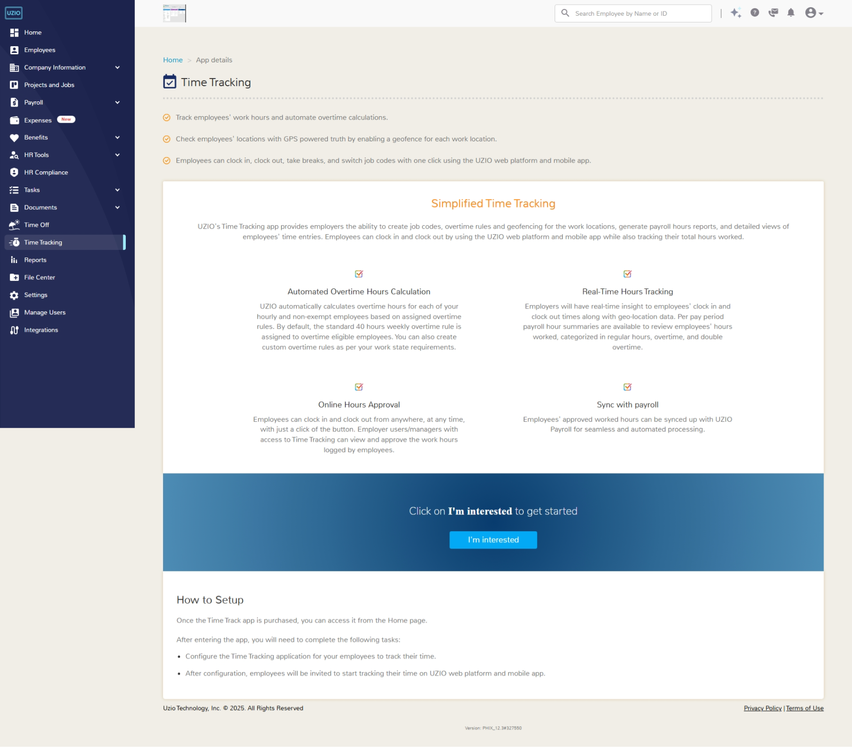

1. UZIO reviews and enables for you.
2. **Log out and Login back in** to load the module.

Once UZIO enables it**,** you’ll see “**Schedule and Time Tracking**” in the left navigation. It's time to configure the time tracking.

## Configuring Time Tracking

Configuring Time Tracking is a one-time, guided setup available after UZIO enables the module. Sign in to the employer portal, open Time Tracking from the left navigation, and click **Get Started**, then complete the following steps-

### **Adding Employees**

Begin by adding employees to Time Tracking. Click **Select Employees** to open the selector, search or filter as needed, and choose the employees to include; confirm to add them to your Time Tracking list.

Prerequisite: Each employee that you are about to add, must be assigned to a pay group with an active payroll calendar—employees without a calendar will not be allowed for selection.

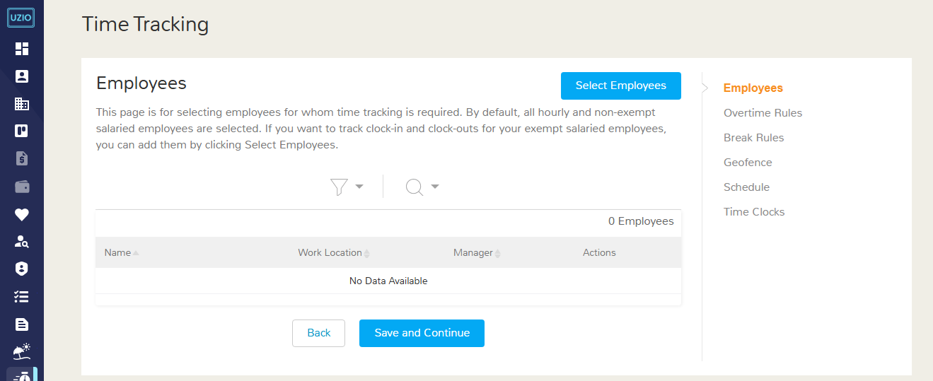

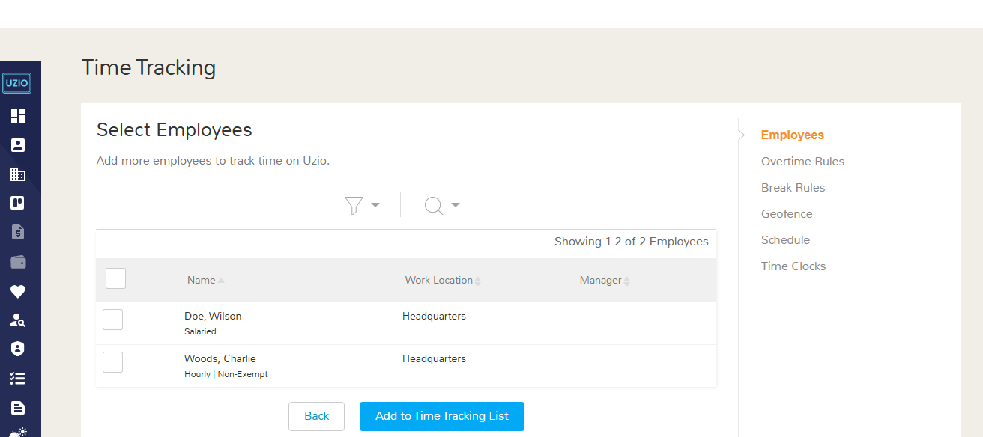

### **Overtime Rules Assignment**

Set how overtime is calculated, then assign the rule to the employees who need it. UZIO includes a built-in **Default** rule—workweek starts **Sunday**, weekly overtime at **40 hours**, and **no** seventh-consecutive-day rule—and all employees are mapped to this by default.

If your policy differs, click **Add Overtime Rule**, enter your parameters (workweek start day, weekly OT threshold, optional daily OT/double-time thresholds, and seventh-day treatment), **save**, and then assign the new rule to the relevant employees.

**Note:** Overtime rules apply to **non-exempt** employees. Exempt salaried employees are typically excluded by company policy.

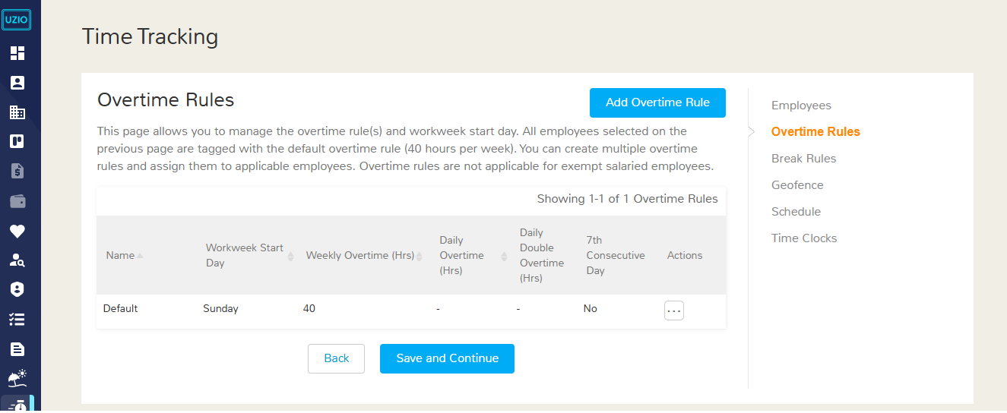

### Break Rule Assignment

Define how employees take and record breaks by creating Break Rules. These rules specify which break types are allowed (paid rest, unpaid meal), their durations, timing windows, and any compliance checks.

No break rules exist by default—and employees cannot record breaks until at least one rule is created and assigned to them.

Click **Add Break Rule**, configure the policy details, save, and assign it to the appropriate employees or groups.

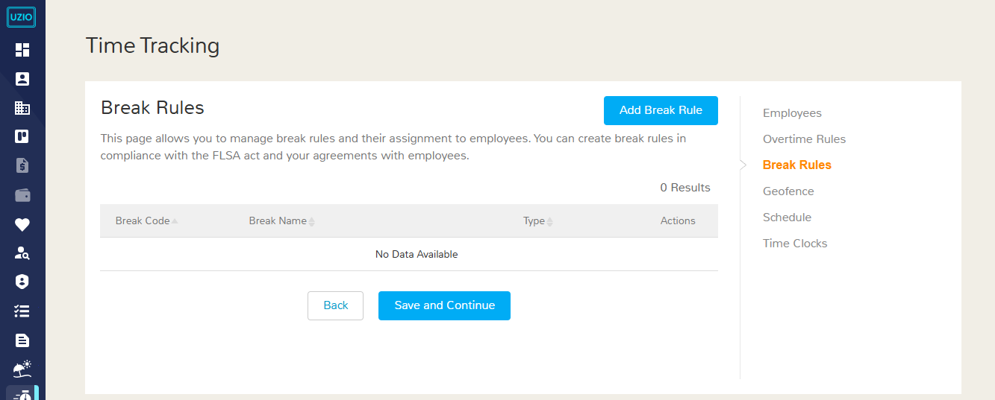

### Geofence Setup

Set location-based clocking boundaries with Geofencing. Define an allowed area around each work location so the system can detect whether employees clock in/out inside or outside that zone. You can choose to restrict punches outside the geofence (block them) or allow but flag them for review. This helps prevent off-site punches and improves the accuracy of time capture.

Select the work location, edit it, enable the geofence and set the geofence radius/area on the map, and save.

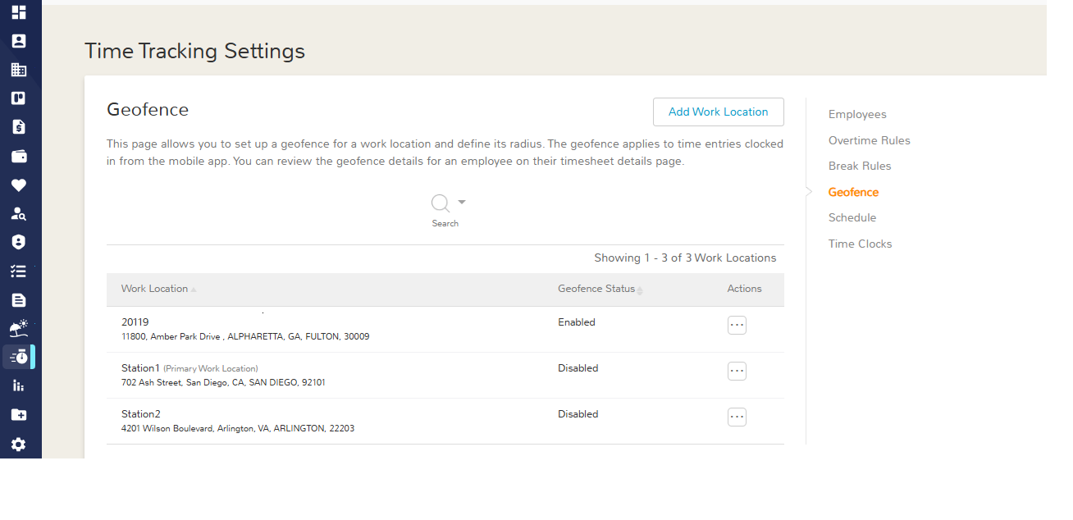

### Schedule Settings

Configure Scheduling only if the Scheduling module is enabled (it becomes available after Time Tracking is enabled).

In this step, review and set your scheduling preferences—choose how and when employees are notified about shifts (publish, reminders before start/end, early/late clock windows) and adjust any general scheduling defaults.

Save your changes to apply them across the roster.

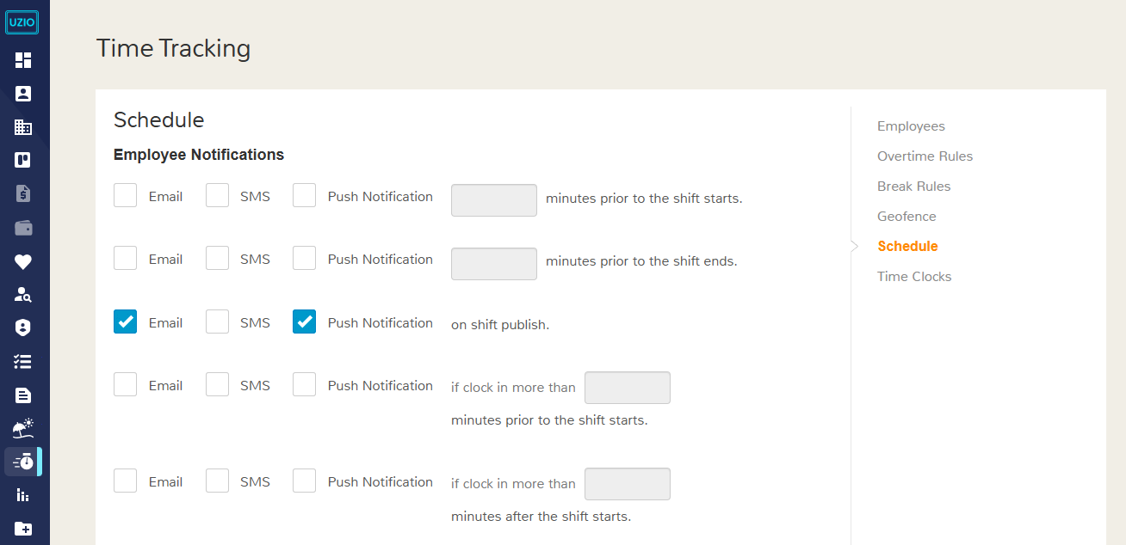

### Time Clocks

Finish by choosing how employees will record time. Enable one or more capture modes—Web, Mobile, and/or Kiosk—based on your environment, then apply the settings to the relevant employees or groups.

For Web, confirm whether punches are allowed or not.For Mobile, confirm whether geofence checks should be enforced at punch time. For Kiosk, create a kiosk station and decide login method and photo security.

After you choose the time clocks, configure the General controls for how time is managed. Decide whether employees can add, edit, or delete their own entries; if allowed, specify whether manager approval is required for any manual add/edit. Require a note whenever an employee or manager changes a time entry, and choose whether employees can view change history. Turn on employee attestation if you want workers to confirm their entries, select the time display format (12-hour or 24-hour), and set the Missing Clock-Out flag to trigger after a defined number of hours from start. Finally, set notifications (Email/SMS/Push) for long-running entries—configure a first and second reminder—and a reminder for missed attestation. Click Save and Publish to apply your settings.

Now your employees are all set to start tracking time.

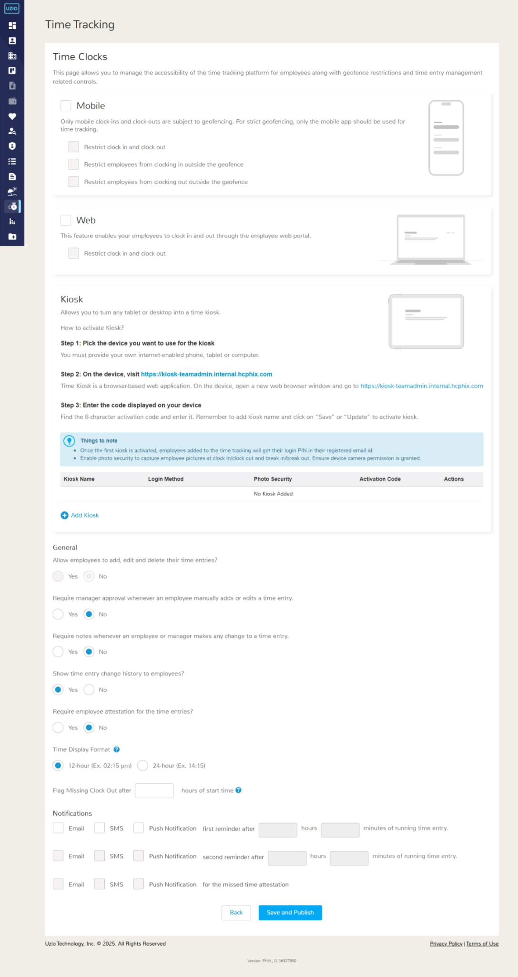

# Roles and Permissions for using Time Tracking

Employer users can perform Time Tracking actions only if their assigned role allows it. What each person can see or do—such as adding entries, editing, approving, running reports or making modifications in the time tracking settings—is determined by the permissions linked to their role. If a permission isn’t granted on the role, the action won’t be available to that user. Employer Administrator can view and manage permissions of the assigned role by navigating as follows

**Log in as Employer -> Locate Manage Users in the Left Navigation -> Locate the role.**

## Managing Employer Settings of Time Tracking

To view or manage company-level Time Tracking items—such as adding employees to Time Tracking, configuring overtime and break rules, setting schedules, defining geofences for work locations, and other settings—open the user’s Role in the Manage User from the left navigation, go to Company Access, and find Schedule & Time Tracking. It may have three possible values

**No Access:** Choose this when the user should have no company-level visibility or control in Time Tracking. They won’t be able to open a Time Tracking Setting page or see any company settings, and they cannot add employees, edit rules, manage schedules, or adjust geofences. (This does not stop them from using personal timesheet features if those are granted access.)

**View Only-**  Choose this when the user should see company-level Time Tracking settings but not change anything. They can open pages that show who’s enabled for Time Tracking, the current overtime and break rules, schedules, geofences and other time tracking settings—but all actions are read-only (no add, edit, or delete).

**Full Access-** Choose this when the user needs to view and update company-level Time Tracking. They can add employees to Time Tracking, create or modify overtime and break rules, manage schedules, set or change geofences for locations, and adjust other configuration settings.

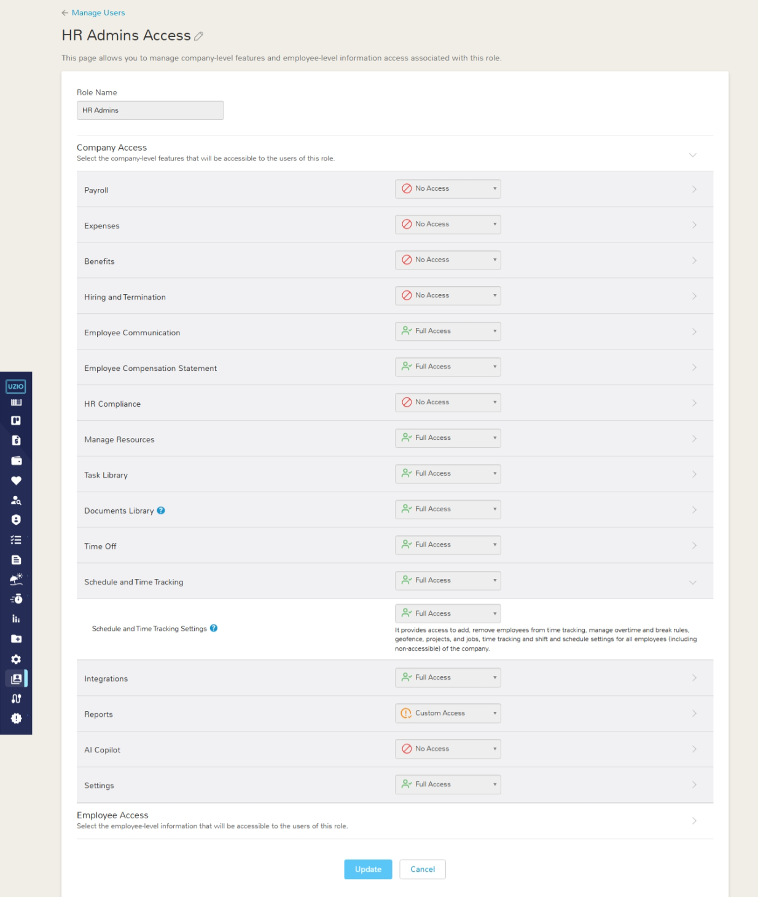

## Managing Employee Timesheet

To view or manage timesheets of **accessible employees**, open the user’s Role in the Manage User from the left navigation, go to Employee Access, and find the Employee **Timesheet** under **Additional Information**. You can manage the ability to view/edit and approve timesheets via this permission. It may have three possible values

**No Access-** Choose this when the user should have no visibility of employees timesheets of accessible employees. The user will no longer see the employee on the Employee’s Timesheet page. This does not stop them from using personal timesheet features if those are granted access.

**View Only-**  Choose this when the user should see the employee's timesheet of accessible employees but not make modifications in the employee timesheet.

**Full Access-** Choose this when the user needs to view and update the employee's timesheet of accessible employees.

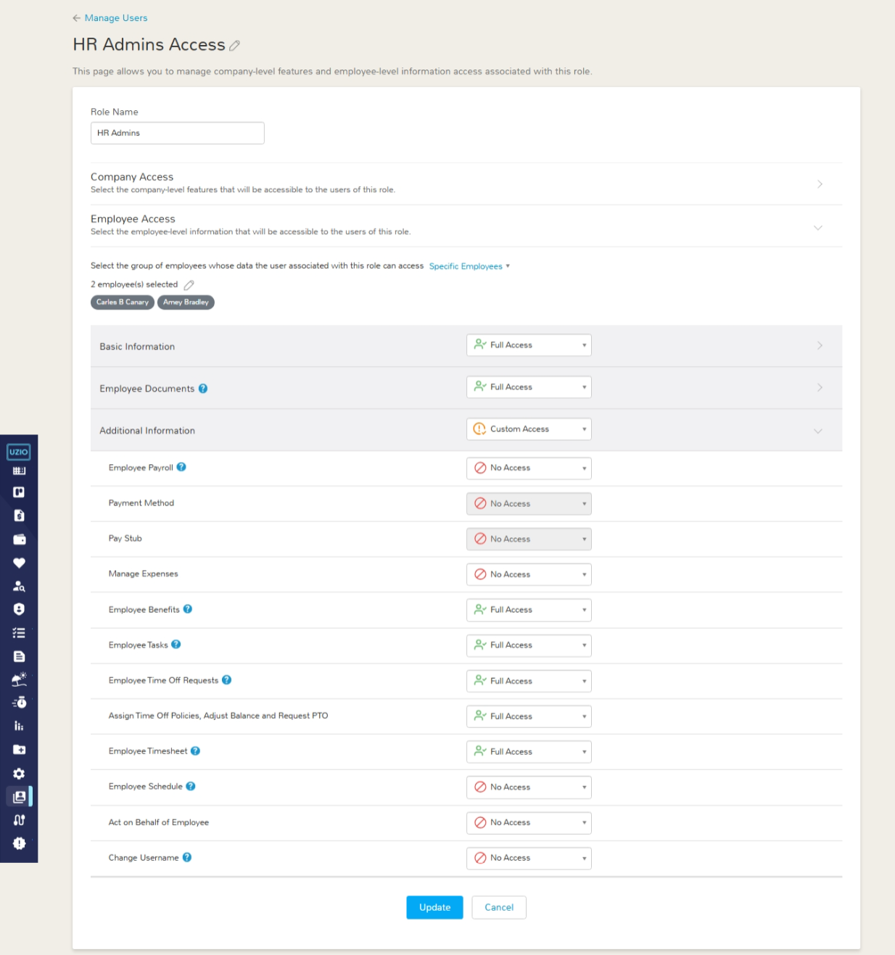

# Managing Employees for Time Tracking

An employee can use the UZIO time tracking module only if the employee is an active employee and added under the time tracking.

## Adding Active Employees

To add active employees into the time tracking follow the steps

* Locate the Time Tracking Settings from the left navigation
* Go to the “Employees” tab on the right.
* Click on the “Select Employees” button. You will see the list of active employees who are currently not added for time tracking.
* Select the employee from here and save. The employee can not track the time now!



Note: You can only add employees to Time Tracking if their pay group has an active payroll calendar. If you try to add someone whose pay group doesn’t have a calendar set up, the system will block the action and show an error. Create the calendar first, then add the employee.

Note: If you hire or add an employee outside the prospective/onboarding journey (which normally prompts you to enable Time Tracking), you must return to Time Tracking Settings and add that employee manually. Until you do, the employee cannot track time in UZIO.

## Adding Prospective Employees

You can add a new hire to **Time Tracking** while setting up their self-onboarding journey. They will not be able to record time until their employment status changes to **Active**, but the assignment is saved in advance.

**Why this helps-** Pre-assigning Time Tracking during onboarding removes a step later—once the employee becomes **Active**, they’re already enabled and can start tracking time immediately.

In the set up self onboarding journey, on the “Time Tools” page, you can select this employee and also can select the overtime rule and break rules.

## Removing Employee from Time Tracking

You can stop someone from tracking time by removing them from Time Tracking. To remove the employee from time tracking, follow the steps

* Open Time Tracking Settings from the left navigation
* Go to the Employees tab
* Find the person in the Selected Employees list
* Open the Actions menu next to their name, and choose **Remove Employee**. The employee will no longer be able to clock in/out or record breaks. You can re-add them later if needed.

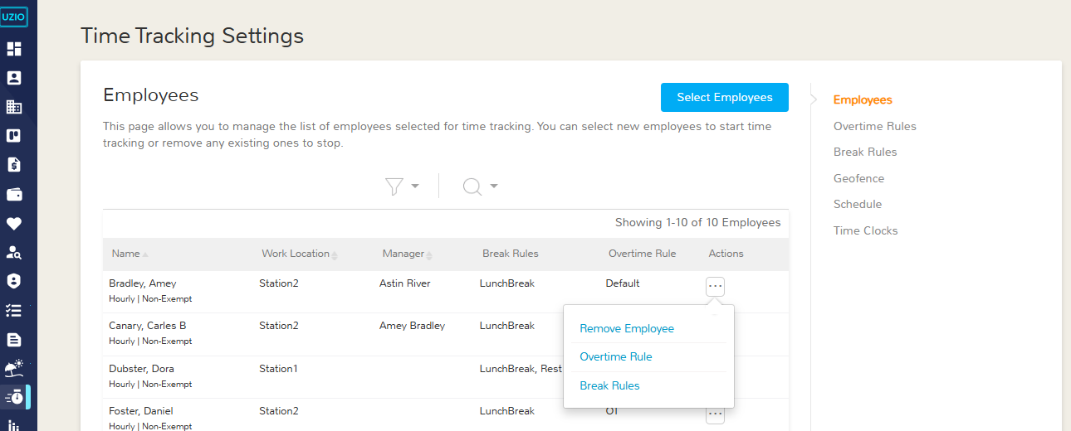

## Change Overtime Rule

You can anytime change the overtime rule of an employee. To change the overtime rule, follow the steps

* Open Time Tracking Settings from the left navigation
* Go to the Employees tab
* Find the person in the Selected Employees list
* Open the Actions menu next to their name, and choose “Overtime Rule”. You can choose only one overtime rule for an employee at a time.



## Change Break Rules

You can anytime change the break rules of an employee. To change the break rules, follow the steps

* Open Time Tracking Settings from the left navigation
* Go to the Employees tab
* Find the person in the Selected Employees list
* Open the Actions menu next to their name, and choose “Break Rules”. You can choose and assign multiple break rules to an employee at a time.



# Overtime Rule Management

This section describes how UZIO lets you configure, assign, update, and control overtime policies in one place. It covers creating overtime rules (workweek start, weekly OT, daily OT, daily double-time, 7th consecutive day OT), assigning them to the right employees in bulk, and editing them prospectively so historical calculations remain unchanged. It also defines when an overtime rule can be deleted (only if it is not assigned), ensuring consistent, compliant, and auditable overtime processing.

## Creating Overtime Rules

UZIO provides the ability to configure rules to calculate overtime and double overtime hours for the hourly employees. You can do so by creating an "Overtime Rule”. To create an overtime rule

* Open Time Tracking Settings from the left navigation
* Go to the Overtime Rules tab
* Click on the “Add Overtime Rule”. The rules has following information

### **Rule Name**

You can give any customized alphanumeric name to the rule.

### Workweek Start Day

The workweek start day sets the window for calculating weekly overtime. If you choose Sunday as the start, each W-2-eligible employee’s weekly pay period runs Sunday through Saturday, and overtime is measured within that exact window.

### Weekly Overtime Start After Hours

You can set the total hours in a workweek after which all additional hours are paid at the overtime rate. Hours worked beyond this weekly threshold are paid at an overtime premium of 1.5× the employee’s regular rate of pay. *Example:* If the weekly threshold is set to 40 hours and an employee works 46 hours in the workweek, the first 40 hours are paid at the regular rate. The remaining 6 hours are paid at the overtime rate of 1.5×.

### Daily Overtime Start After Hours

You can set the total number of hours in a single workday after which additional hours are paid at the overtime rate. All hours worked beyond the weekly threshold are paid at an overtime rate of 1.5× the employee’s regular hourly rate. Example: If daily overtime begins after 8 hours and an employee works 9.5 hours on Tuesday, the first 8 hours are paid at the regular rate. The additional 1.5 hours that day are paid at 1.5×.

### Daily Double Overtime Start After Hours

You can set the total number of hours in a single workday after which additional hours are paid at the double overtime rate. All hours worked beyond the weekly threshold are paid at an overtime rate of 2× the employee’s regular hourly rate. Example: If daily overtime begins after 8 hours and double time begins after 12 hours, and an employee works 13 hours on Friday, pay the first 8 hours at the regular rate, hours 9–12 at 1.5×, and hour 13 at 2×.

### 7th Consecutive Day Overtime

In certain states, when a non-exempt employee works seven consecutive days in the same workweek, the hours worked on the seventh day must be paid at an overtime premium of 1.5× the employee’s regular hourly rate (subject to local law and your company policy). Configure the 7th Consecutive Day option in your overtime settings to apply this automatically. Example: If the workweek runs Sunday through Saturday and an employee works all seven days, the seventh day becomes overtime-eligible. For example, if they work 6 hours on Day 7, those 6 hours are paid at 1.5× (and, if your policy/state requires it, hours beyond 8 on Day 7 would be paid at 2×).

### Assign To

You can assign the overtime rules in bulk. Select the employees to whom the rule applies.

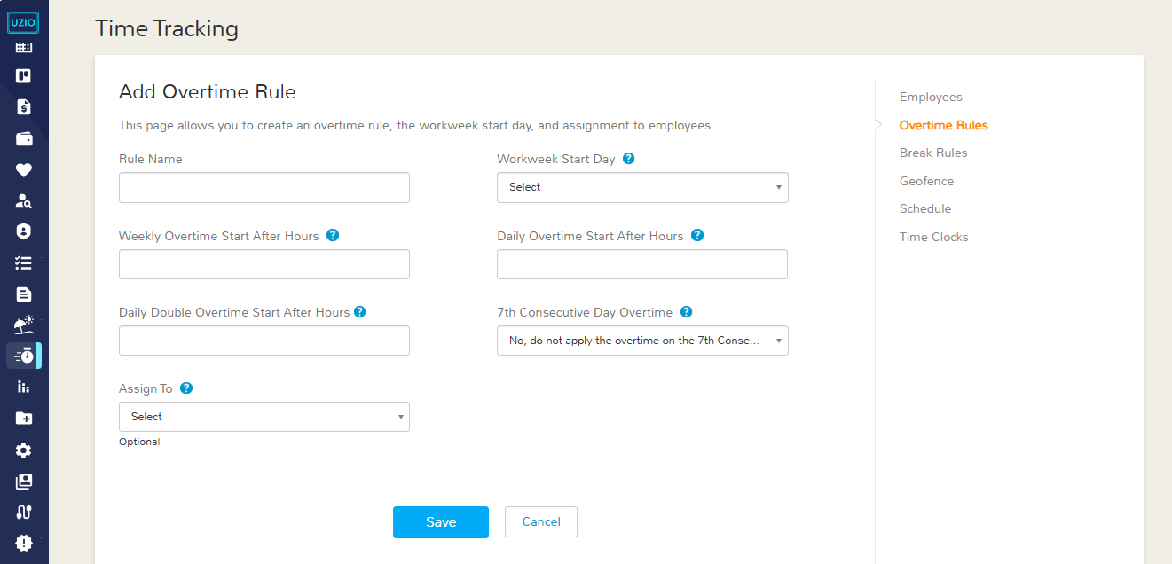

## Editing an Overtime Rule

Employers can update Overtime Rules at any time if policies change or if a correction is needed. To edit a rule,

* Go to **Time Tracking Settings** from the left navigation
* Open the **Overtime Rules** tab
* Locate the specific Overtime Rule, and click **Edit** from the Actions menu. You can modify items such as Weekly Overtime Start, Daily Overtime Start , Daily Double Overtime and 7th Consecutive Day Overtime.

When you save changes, the new version of the rule will apply going forward. Time entries that already exist are not reprocessed. This means any older entries that were already evaluated for Overtime hours or Double overtime hours will remain exactly as they were under the original settings. Only time entries created or edited after the update will use the revised rule. This protects historical records and prevents retroactive payroll changes.

## Deleting Overtime Rules

To delete an overtime rule

* Go to **Time Tracking Settings** from the left navigation
* Open the **Overtime Rules** tab
* Locate the specific Overtime Rule, and click **Delete** from the Actions menu. You can not delete the overtime rule, if it is assigned to any employee.

## Overtime Pay

Overtime pay, as described by the FLSA (Fair Labor Standards Act) is awarded to non-exempt employees who qualify for overtime pay. Overtime pay for non-exempt employees is calculated at one-and-a-half times (1.5x) their hourly rate, for every work hour beyond the standard 40-hour week. Once you have determined overtime eligibility, calculating overtime pay is simple.

### What is Blended Rates of Overtime Pay

The federal government’s Fair Labor Standards Act requires that when work is performed at two or more rates, overtime must be paid out at a blended rate. A “blended rate” is a rate of not less than one-and-a-half times the weighted average of all non-overtime rates used during that workweek.

### When is a Blended Rate Required?

For most employers, calculating overtime is straightforward: employees receive one-and-a-half times their regular rate of pay for all hours worked over 40 hours. However, this becomes more complicated for employers that have employees that work different jobs at different rates. You may have employees that perform different jobs or tasks at different rates.

### **Weighted vs Blended Overtime - Are They the Same?**

Yes, blended overtime is often referred to as weighted or weighted average. It gets its name because a weighted average of two different pay rates is used to determine the overtime rate.

### **How to Calculate a Blended (Weighted Average) Overtime Rates**

You can follow the steps in the example below to calculate overtime with two different pay rates:

Let’s say David is an hourly employee who worked a total of 50 hours in a workweek at two different jobs having different hourly rates as shown in the grid below.

| **Job** | **Rate/Hr.** | **Regular Hours** | **Overtime Hours** | **DOT Hours** | **Total** |
| --- | --- | --- | --- | --- | --- |
| Driver | $10 | 25 | 5 | 0 | 30 |
| Cleaner | $20 | 15 | 5 | 0 | 20 |
|  |  |  |  |  |  |
|  |  |  |  |  |  |
|  |  |  |  |  |  |

David works a total of 30 hours for a Driver job out of which 25 hours are regular and 5 hours are overtime at a rate of $10 per hour. As a Cleaner, he works a total of 20 hours, out of which 15 hours are regular and 5 hours are overtime at a rate of $20 per hour.

First, the employee’s weighted average is determined. Once it is available, then each respective job’s overtime hours are paid at a weighted overtime rate. Example:

**Step 1:** Calculate the straight wage by multiplying the total hours worked for each job with each job’s respective hourly rate:

(30 hrs. x $10) + (20 hrs. x $20) = $700

**Step 2:** Divide the total straight wage calculated in **Step 1** by total work (Regular + OT + DOT) hours to find blended rate.

$700/50 hrs. =$14/hr

**Step 3:** To get the weighted overtime rate for one job, divide the average weighted blended rate from **Step 2** by 2 and add it to the individual job rate.

$14/2 =$7/hr

**Step 4:** We got 0.5 (half) the blended rate in **Step 3**. Now, add this 0.5x blended rate into each job's regular rate to get blended overtime rates for each job.

Driver Job rates are:

* Regular Rate: $10/hr
* Blended Overtime Rate: $17/hr ($10+$7)
* Blended Double Overtime Rate: $24/hr ($10 + $14)

Cleaner Job rates are:

* Blended Regular: $20/hr
* Blended Overtime: $27/hr ($30+$7)
* Blended Double Overtime: $34/hr ($20 + $14)

Employee’s total wages for multi-job rate scenarios will be (OT = Overtime, DOT = Double Overtime):

(Driver Reg Hours x Reg Rate) + (Driver OT Hours x Blended OT Rate) + (Driver DOT Hours x Blended DOT Rate)

+

(Cleaner Reg Hours x Reg Rate) + (Cleaner OT Hours x Blended OT Rate) + (Cleaner DOT Hours x Blended DOT Rate)

(25 hrs. x $10) + (5 hrs. x $17) + (0 hrs. x $24)

+

(15 hrs. x $20) + (5 hrs. x $27) + (0 hrs. x $34)

=**$770**

# Break Management

This section describes how UZIO lets you define, assign, and control break policies in a centralized, consistent way. It covers creating Break Rules (paid vs unpaid, eligibility windows, durations, guardrails like prevent early/short breaks, auto-end, and missed/short/long-break handling), assigning them to the right employees or groups, and configuring options such as premiums, notifications, and break attestation.

## Creating Break Rules

Break Rules define your **paid rest** and **unpaid meal** policies—types, durations, timing windows, eligibility. UZIO does not create break rules automatically; employees cannot record breaks until a rule is created and assigned.It’s recommended to configure rules to match state/industry laws—this improves compliance, creates a consistent employee experience, and reduces payroll disputes.

* You can configure break policies by creating "Break Rule”. To create a break rule, Open Time Tracking Settings from the left navigation
* Go to the Break Rules tab
* Click on the “Add Break Rule”.

The following information is mandatory to create a break

### Break Code

An alphanumeric break code to uniquely identify a break in your organization.

### Break Name

An alphanumeric break name that employees will see while punched in.

### Break Category

UZIO supports two break categories - Meal and Rest. You can create multiple breaks under each category. A break category is used to group the same kind of break under one category.

### Break Type

UZIO supports two break types: **Paid** and **Unpaid**.

**Paid Breaks-** These are considered working hours, meaning employees are compensated for this time. They are also factored into calculations for overtime and double-time pay.

**Unpaid Breaks**- These are not considered working hours, are not compensated, and are excluded from all overtime and double-time calculations.

### Break Duration

Enter the break duration in minutes. UZIO uses this value to evaluate exceptions—such as short or long breaks—to auto-end breaks when they exceed limits, and to prevent short breaks when guardrails are enabled. The duration also drives break notifications (for reminders alerts). If the Prevent Early Break guardrail is not configured, employees can end a break shorter or longer than the set duration.

### Break Eligibility Window

Break Eligibility window is the minimum working time an employee must complete in a shift before a break becomes due. UZIO supports two settings to define the break eligibility windows.

**Employees receive a break if they work more than ___ hours and ___ minutes**

This setting defines the first break eligibility window. UZIO does not prevent the employee from taking the break before the eligible window. When an employee works more than continuous *X hours Y minutes*, UZIO marks the break as eligible, if not taken, allowing the system to flag a missed break and calculate any configured premium.

**Example**If the threshold is 5 hours 0 minutes, an employee becomes eligible for the break after 5:00:00 of worked time. If they don’t start a break before 5 hours, UZIO can send notifications and, based on your rules, record it like a missed break.

**Repeat break for every __ hours and ___ minutes**

This setting defines the subsequent break eligibility windows. The functionality remains the same as defined above.

### Resolving Missed Breaks

The **Resolving Missed Breaks** section controls what UZIO should do when an employee does not take a break within the eligible window. Here you choose whether the system auto-deducts a missed break or simply flags it for review, sets the point at which a break is auto inserted or flagged as missed, and defines any premium to award for each missed break. You can also require break attestation so employees or managers record a reason when a break is missed. These settings ensure missed breaks are handled consistently for payroll, compliance, and audit purposes.

#### **Auto Deduct/Flag**

Choose the automatic action UZIO takes when a break isn’t taken within the eligible window.

* Deduct Missing Break - The system inserts a missed-break deduction into the time entry (per your rule’s duration/type), which adjusts worked time and payroll totals accordingly.
* Flag Missing Break - The system does not change the time entry but adds a missed-break for review and follow-up.

#### Deduct/Flag Missing Break at

Choose at what time, UZIO should place or flag the missed-break inside the time entry when a break isn’t taken within the eligible window.

* Starting of Time Entry — Inserts or flags the missed break at the start time of the eligible window. Example- If the eligible window of the break is 9AM to 2PM and the break duration is 30 Minutes, the missed break will be inserted or flagged from 9AM to 9:30 AM.
* Middle of Time Entry — Inserts or flags the missed break at the midpoint of the eligible window. Example- If the eligible window of the break is 9AM to 2PM and the break duration is 30 Minutes, the missed break will be Inserted or flagged from 11:30AM to 12:00 AM.
* End of Time Entry — Inserts or flags the missed break at end of the eligible window.Example- If the eligible window of the break is 9AM to 2PM and the break duration is 30 Minutes, the missed break will be Inserted or flagged from 1:30PM to 2:00 PM.
* Custom Hours — Inserts or flags the missed break at a specific offset from the start (e.g., at 1:00 hours). Use this when policy requires the missed break to be recorded at a specific time. Example- If the eligible window of the break is 9AM to 2PM and the break duration is 30 Minutes and the custom time defined in this setting is 1 Hour, the missed break will be Inserted or flagged from 10 AM to 10:30 AM.

#### Break Premium

Use the setting **Award a premium of __ hours and ___ minutes for each missed break** to automatically add extra paid time to the time entry whenever a break is missed. Enter the premium duration (hours and minutes); the amount is applied per missed break and added to paid time, and sent to payroll with the designated earning code. The system applies the capping of 1 Hour on the total no. of premium hours per break category per time entry.

*Example:* If the premium is 1hour and two breaks are missed, the entry receives 2 hours of premium pay but since it is capped at 1 hour, so the final premium would be 1 hour.

#### Break Attestation

When the setting **Break Attestation Required is** enabled, UZIO evaluates at **clock-out** whether the employee took the break within the **eligible window**. If not, the employee sees an attestation prompt. For each missed break, they can choose one of three actions:

1. Add the break to the time entry (insert the missed break per your rule) by selecting the choice “**Yes, I took this break.**”,
2. Confirm it was missed due to work by selecting “**No, I was prevented by work from taking this break.**”
3. Confirm it was missed by choice by selecting “**I had the opportunity, but I freely chose not to take this break.**”

UZIO records the selection (and any notes) on the time entry for audit/compliance and applies your policy—such as premiums —accordingly.

### Break Guardrails

#### Prevent starting early breaks

Use the setting **Allow break only after __ hours __ minutes from the start of the time entry** to prevent starting an early break. Sets a minimum wait time before a break can start. Employees cannot begin this break until *X hours Y minutes* have elapsed from the clock-in time; the system shows a validation on taking the break before that point.

*Example:* If set to 2 hours 0 minutes and the shift starts at 9:00 AM, the break can’t start before 11:00 AM.

#### Prevent Early Break End**.**

Use this guardrail to block early break endings. When enabled, an employee cannot end a break before the scheduled duration has elapsed.

Example: If the break duration is 30 minutes and the break starts at 9:30 AM, the system will not allow the employee to end it before 10:00 AM.

#### Automatically end break when duration ends

Use this guardrail to end the break automatically when the scheduled end time (Start time +Duration) is reached. It ensures compliance with Short Break. Example: Break starts at 9:30 AM, duration 30 minutes (scheduled end 10:00 AM). Break will automatically end at 10AM.

#### Short Break

Use the guardrail **Flag Break as Short if break ends before __ minutes** to flag a break as “Short” when an employee ends it too early relative to its scheduled end time (start time + duration). You set an early-end variance in minutes; if the break ends earlier than scheduled end − variance, UZIO marks it as Short.

Example: Break starts at 9:30 AM, duration 30 minutes (scheduled end 10:00 AM), variance 10 minutes. If the employee ends the break before 9:50 AM, the system flags it as a Short Break.

#### Long Break

Use the guardrail **Flag Break as Long if break ends after__ minutes** to flag a break as “Long” when an employee ends it late relative to its scheduled end time (start time + duration). You set a late-end variance in minutes; if the break ends after the scheduled end + variance, UZIO marks it as Long.

Example: Break starts at 9:30 AM, duration 30 minutes (scheduled end 10:00 AM), variance 10 minutes. If the employee ends the break after 10:10 AM, the system flags it as a Long Break.

### Break Notifications for Employees

#### Break Start Notification

Use the setting **Email/SMS/PUSH notifications ___ minutes before the break start time** to send the start break notification.If an employee hasn’t started the break by the end of the eligible window, UZIO can send a “Start Break” reminder so the full break still fits within the window. You choose the channels—Email, SMS, and/or Mobile Push—and a lead time (minutes) before the window ends. The reminder time is calculated as: window end time minus break duration minus lead time.

Example: Break duration = 30 min, eligible window = 9:00 AM–2:00 PM, lead time = 10 min. A reminder is sent at 2:00 PM − 30 min − 10 min = 1:20 PM, ensuring the employee can take a full 30-minute break and finish by 2:00 PM.

**Sample Email**

*Subject- Reminder: Meal Break is about to start*

*Body- Hello Rowan,*

*You're eligible for Meal Break in next 10 minutes at 01:30 PM. Please take your scheduled break to stay compliant with work hour guidelines.Click here to login.*

*Thank You*

*Team UZIO*

**Sample SMS**

*You are eligible for Meal Break in 10 minutes*

**Sample Push Notification**

***Meal Break is about to start***

*You are eligible for meal break in 10 minutes*

#### Break End Notification

Use the setting **Email/SMS/PUSH notifications ___ minutes before the break end time** to send the start break notification. If an employee has started the break, UZIO can send an “End Break” reminder so the employee does not miss to end the break within time. You choose the channels—Email, SMS, and/or Mobile Push—and a lead time (minutes) before the duration ends. The reminder time is calculated as: Break Start time + Duration defined in the break minus lead time.

Example: Break duration = 30 min, Break started at 1:30 PM, Duration =30 Mins, lead time = 10 min. A reminder is sent at 01:30 PM + 30 Mins - 10 Mins= 1:50 PM, ensuring the employee can end the break on time.

**Sample Email**

Subject- Reminder: Meal Break is about to end

Body-

Hello Rowan,

This is a gentle reminder to end your Meal Break in next 10 minutes at 02:00 PM and resume your shift. Click here to login.

Thank You

Team UZIO

**Sample SMS**

End your Meal Break in 10 minutes and resume your shift

**Sample Push Notification**

**Meal Break is about to end**

End your Meal Break in 10 minutes and resume your shift

#### Missed Break Notification for employee

Use the setting **Email/SMS/PUSH notifications for missed break** to send the missed break notification. If an employee hasn’t started the break by the end of the eligible window, UZIO can send a “Missed Break” reminder. You choose the channels—Email, SMS, and/or Mobile Push. The reminder is sent at the end of the eligible window.

Example: Eligible window = 9:00 AM–2:00 PM Missed break reminder is sent at 2:00 PM.

**Sample Email**

*Subject- Alert: Meal Break is missed*

*Body-*

*Hello Rowan,*

*Our record indicates that you didn’t take your scheduled Meal Break on 09/11/2025 from 01:30 PM to 02:00 PM. Please make sure to take your breaks to stay compliant with company policy. Click here to login.*

*Thank You*

*Team UZIO*

**Sample SMS**

*You missed your scheduled [Break Name] on [Date] from 01:30 PM to 02:00 PM*

**Sample Push Notification**

*Meal Break is missed*

*You missed your scheduled Meal Break on 09/11/2025 from 01:30 PM to 02:00 PM*

### Break Notifications for Manager

#### Missed break Notification for manager

Use the setting **Email/SMS/PUSH notifications for missed break** to send the missed break. If a direct report hasn’t started the break by the end of the eligible window, UZIO can send a “Missed Break” reminder to the reporting manager. You choose the channels—Email, SMS, and/or Mobile Push. The reminder is sent at the end of the eligible window.

Example: Eligible window = 9:00 AM–2:00 PM Missed break reminder is sent at 2:00 PM.

**Sample Email**

Subject- Alert: Rowan Doe has missed the <Break name>

Body- Hello James,

Our record indicates that Rowan didn’t take the scheduled Meal Break on 09/11/2025 from 01:30 PM to 02:00 PM. Click here to view details.

Thank You

Team UZIO

**Sample SMS**

Rowan Doe missed scheduled Meal Break on 09/11/1025 from 01:30 PM t0 02:00 PM.

**Sample Push Notification**

**Rowan Doe has missed the Meal Break**

Rowan Doe missed scheduled Meal Break on 09/11/1025 from 01:30 PM t0 02:00 PM.

### Break Assignment

#### Break Rule Assignment

Break rules can be assigned to employees using the following options:

1. **Assignment** section on the **Break Rule** page  
   On the **Break Rule** page, there is an **Assignment section** where you can assign the break rule to employees. You can assign the rule to individual employees or a group of employees in a single step.
   * If needed, you can also **remove** an already assigned break rule from an employee directly from this section.

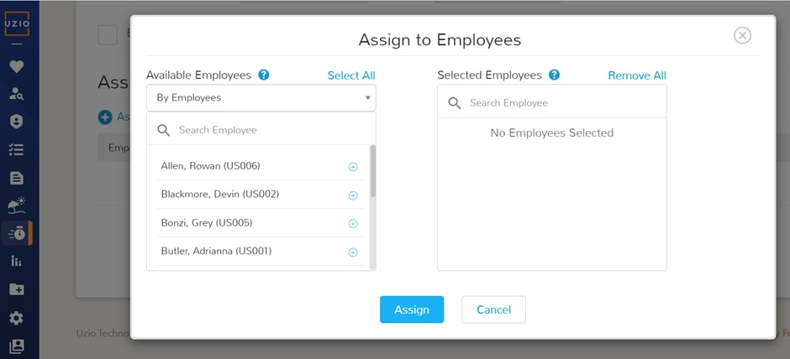

1. **Employee List in Time Tracking Settings**In the **Time Tracking Settings**, there is an **Employees** page that displays a list of employees enabled for time tracking. From this page, you can manage to break rules for individual employees.

* Use the available **actions** next to each employee's name to **assign or remove** break rules as needed.

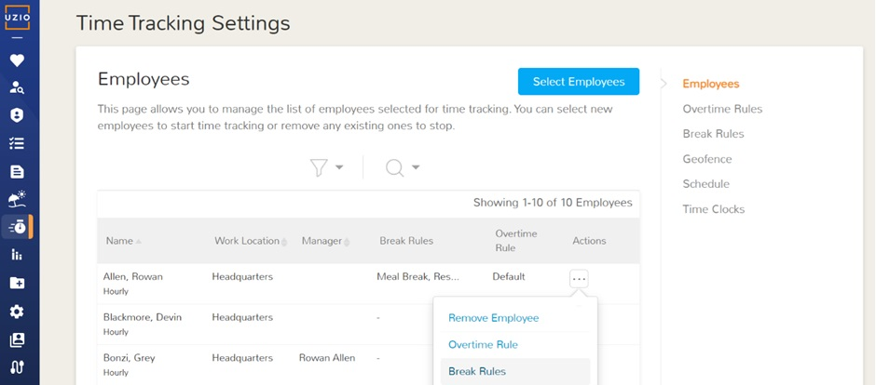

This streamlined process ensures easy management of break rules across individual employees or entire groups.

## Editing Break Rules

Employers can update Break Rules at any time if policies change or if a correction is needed. To edit a rule

* Go to **Time Tracking Settings** from the left navigation
* Open the **Breaks** tab
* Locate the specific Break Rule, and click **Edit** from the Actions menu. You can modify items such as eligibility windows, break duration, guardrails, missed-break handling, premiums, and attestation requirements.

When you save changes, the new version of the rule will apply going forward. Time entries that already exist are not reprocessed. This means any older entries that were already evaluated for missed, short, or long breaks — and any premiums that were calculated — will remain exactly as they were under the original settings. Only time entries created or edited after the update will use the revised rule. This protects historical records and prevents retroactive payroll changes.

## Deleting Break Rules

To delete a break rule

* Go to Time Tracking Settings from left navigation
* Open the Breaks tab on the right
* Locate the specific Break Rule, and click Delete from the Actions menu. Once you delete the break rule, it will be unassigned from all the employees.

When you delete the rule, Time entries that already exist are not reprocessed. This means any older entries that were already evaluated for missed, short, or long breaks — and any premiums that were calculated — will remain exactly as they were under the original settings.

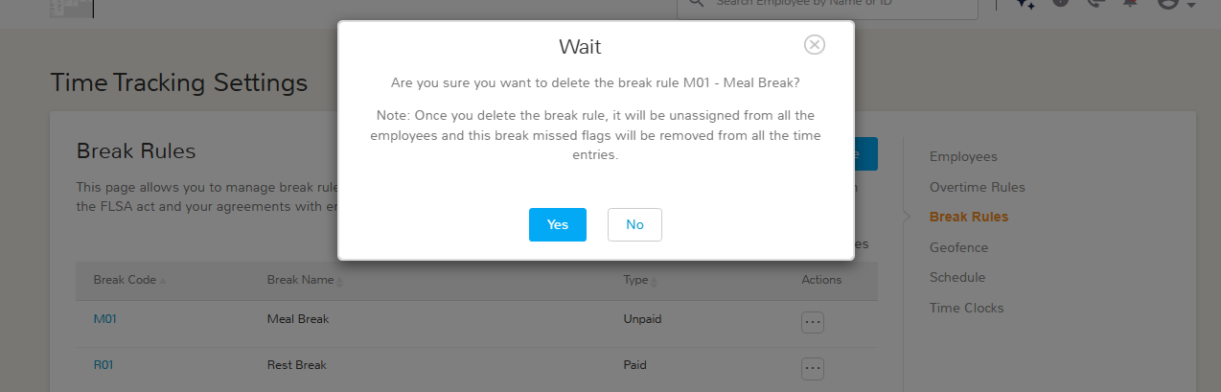

# Geofence Management

## Configuring Geofence

Set location-based clocking boundaries with Geofencing. Define an allowed area around each work location so the system can detect whether employees clock in/out inside or outside that zone. You can choose to restrict punches outside the geofence (block them) or allow but flag them for review. This helps prevent off-site punches and improves the accuracy of time capture.

* To enable the geofence for a work location
* Open Time Tracking Settings from the left navigation
* Go to the “Geofence” tab
* Locate the work location, open the Actions menu for the work location and choose Edit. A pop-up appears with the location’s address prefilled.
* Check Enable Geofence, then select a geofence type: Circular or Polygon. The map pointer marks the current work location address—move it first if the pin isn’t exactly where you want the boundary.
  + If you choose **Circular**, set the radius around the pin to define the allowed clock-in/out area. The maximum limit of radius is 1000 meters.
  + If you choose **Polygon**, draw a closed boundary around the pin: click once to start, click each corner of the perimeter, then click the starting point again to close the shape. (If the pin is off, reposition it before drawing.)
* Review the boundary and Save. Punches outside the fence will follow your geofence rules (e.g., blocked or allowed but flagged)

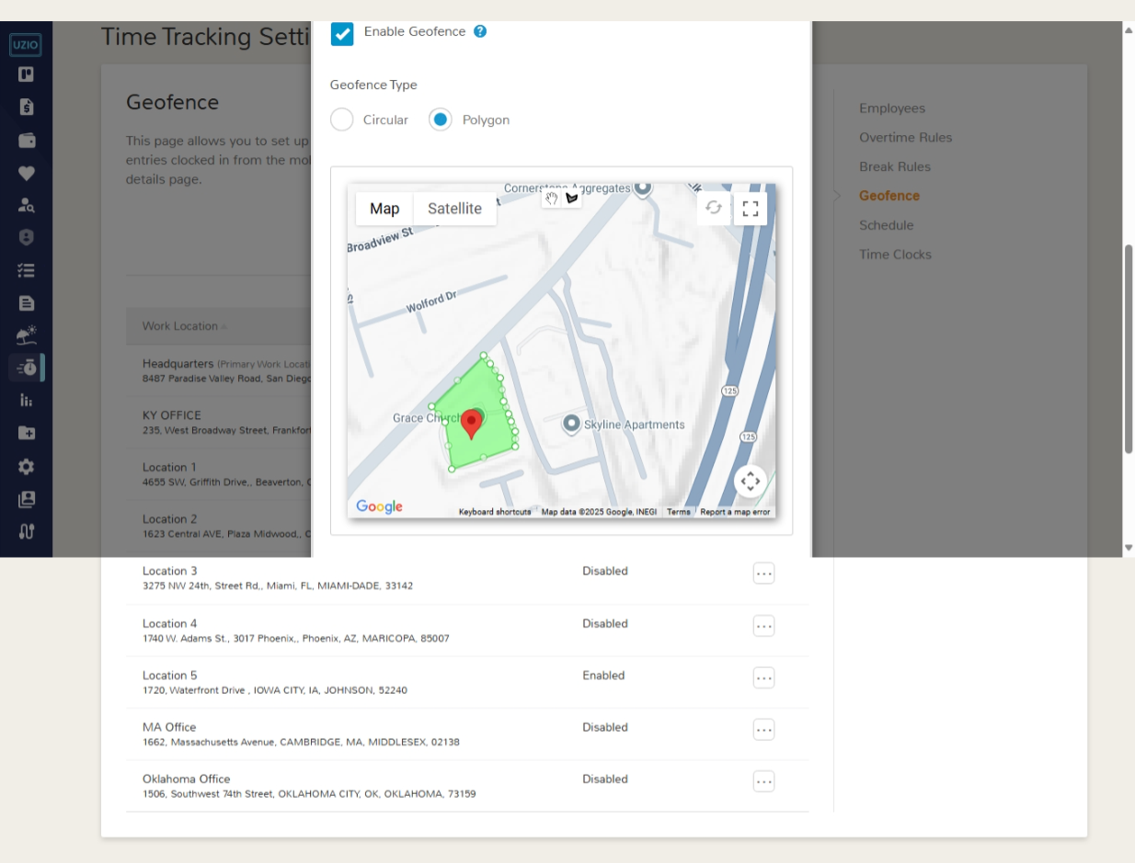

### Restrict Clock In/Clock Out outside the geofence boundary

To restrict Clock In/Clock Out outside the geofence boundary

* Open Time Tracking Settings from the left navigation
* Go to the “Time Clocks” tab
* Under the time clock “Mobile”, select the checkbox “Restrict employees from clocking in outside the geofence” or “Restrict employees from clocking out outside the geofence”.
* Save the changes

# Time Clocks and General Settings

To enable the following settings

* Open Time Tracking Settings from the left navigation
* Go to the “Time Clocks” tab and locate the setting defined below.

## Enable Time Tracking by Mobile

Select the Mobile option to enable UZIO’s mobile app access to employees for time tracking activities. By default, users can view and manage their timesheets and punch in/out in the mobile app both inside and outside any geofence. If you need tighter control, you can restrict these actions by adjusting the settings below.

* Restrict clock in and clock out
* Restrict employees from clocking in outside the geofence
* Restrict employees from clocking out outside the geofence

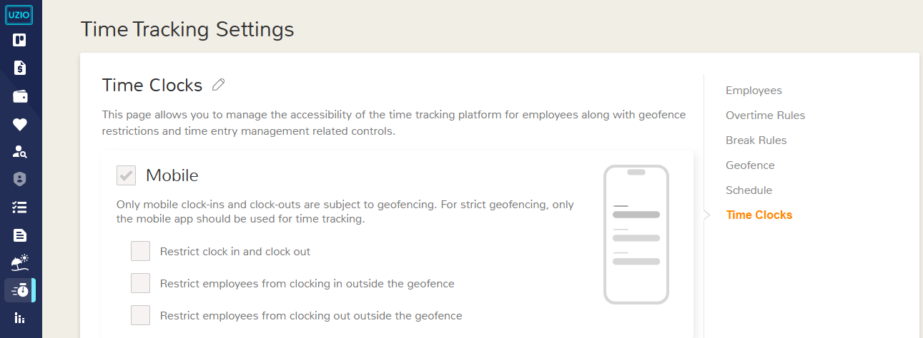

## Enable Time Tracking by Web

Select the Web option to enable UZIO’s web platform access to employees for time tracking activities. By default, users can view and manage their timesheets and punch in/out in the web app. If you need tighter control, you can restrict these actions by adjusting the settings below.

* Restrict clock in and clock out

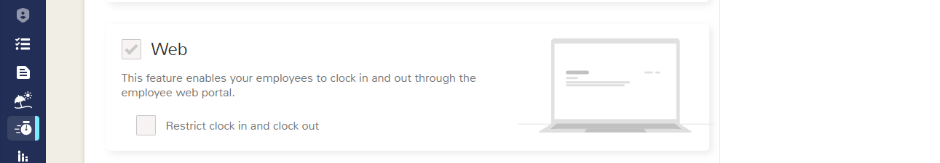

## Enable Time Tracking by Kiosk

If you want to set up a kiosk at your work location, you have to set it up here first. Follow the steps below -

To set up a new kiosk for time tracking

* Go to Time Tracking Settings from the left navigation
* Go to Time Clocks tab
* Under the Kiosk section click on the link “Add Kiosk”. On click of this, a row will appear where you need to enter following inputs

### **Kiosk Name**

* + - Enter the desired kiosk name, example the Location’s Name.

### **Login Method**

* + - Login method is the mechanism by which the employees will be able to login into the kiosk. It has two options-
    - **PIN**- By selecting this, the employees will be able to login only by PIN given to them by the UZIO system.
    - **Face Unlock or PIN**- By selecting this, the employees will be able to login PIN given to them by UZIO system or by facial recognition. Make sure the device is camera enabled and the permission for using the camera is granted.

### **Photo Security**

* + - Enable this feature for added verification during clock-in/out. This setting ensures that a photo is captured and stored with each time entry, giving you added peace of mind regarding the authenticity of time logs.

### **Activation Code**

* + - To activate the kiosk on a device, take the device and open a browser on the selected device (ideally a tablet) and navigate to[kiosk.uzio.com](http://kiosk.uzio.com). A unique Activation Code will be displayed on the browser. Enter this code in the Activation Code field during kiosk setup.

### **Consent**

* + - If you choose Face Unlock or PIN as your login method—or if you enable Photo Security—you must first review and accept UZIO’s Biometric Policy and Terms of Use. This consent confirms you understand how your data is used and allows these security features to function.

Once the first kiosk is activated, employees added to the time tracking will get their login PIN in their registered email id. 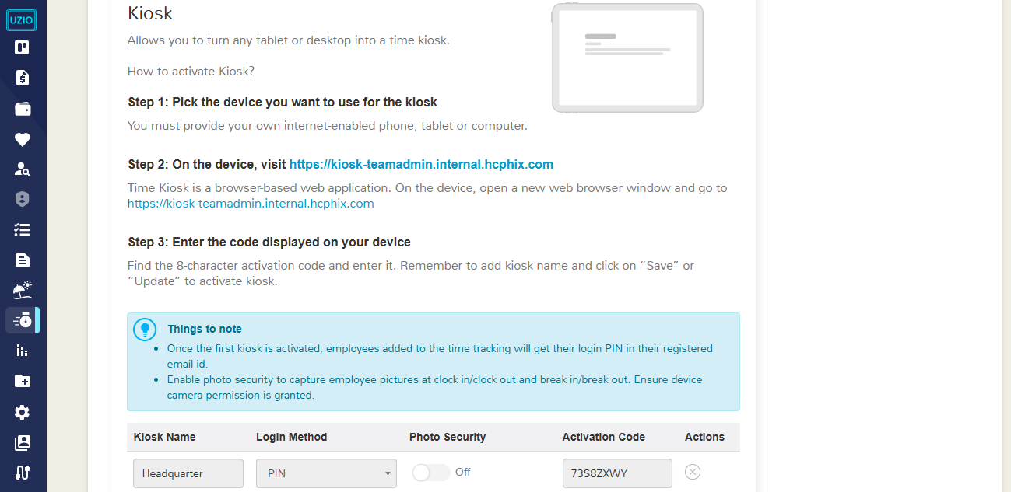

## General Settings

### **Notes on Timesheet Modification**

***Require notes whenever an employee or manager makes any change to a time entry*** Enable this to force a reason/note whenever an employee or manager adds, edits, or deletes a time entry. The note is stored with the change in the audit trail and can be surfaced in reports for review. This improves transparency, speeds approvals, and reduces back-and-forth on why a correction was made.

An employee can add a note while adding/editing a time entry or by an action on an entry named “**Add Notes**”. When an employee adds a note to a time entry, UZIO displays an orange “Notes” icon to indicate the note is unread. Managers can open the entry and click “**Mark as Read**” in the notes section of the entry. Once marked, the icon changes to gray, confirming the note has been reviewed. This visual status helps managers quickly distinguish new notes from those already acknowledged.

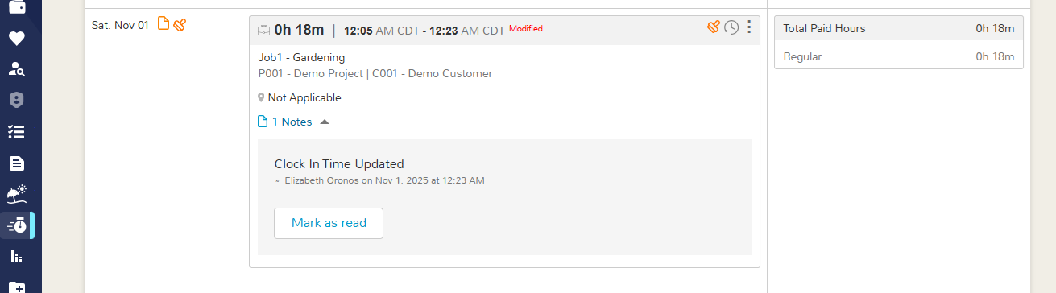

### **Time Display Format**

Choose how times appear across timesheets, approvals, reports, and kiosks. 12-hour (e.g., 02:15 PM) or 24-hour (e.g., 14:15). This setting affects display only—it doesn’t change how hours are calculated. Select your preferred format and save.

### Flag Missing Clock Out

**Flag Missing Clock Out after ___ hours of start time.** Set the number of hours after clock-in when UZIO should mark a time entry as missing a clock-out. Once the threshold is reached, the entry is flagged so managers can follow up or clock out. Allows managers or employees to add clock out time. Also allows employees to clock in for a new shift even if a previous clock-out is missing. Example: If set to 12 hours and the employee clocked in at 9:00 AM, the entry is flagged at 9:00 PM if no clock-out exists and later on employee or manager can add the time.

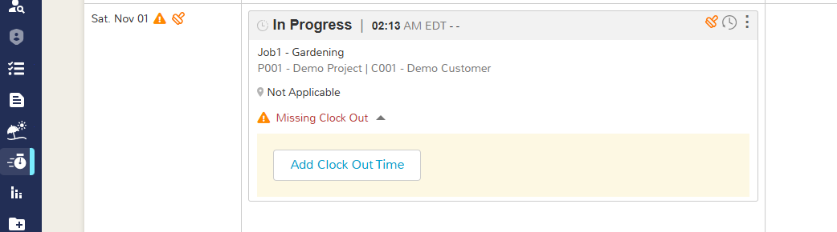

### **Long Running Time Entry Notification**

UZIO can send two reminders when an employee has a running time entry beyond a set duration—one to the employee and one to the manager. Use these alerts to catch missed clock-outs and prevent inflated hours.

To configure the timing, open Time Tracking Settings → Time Clocks and enter the thresholds for each reminder. The default timings are 10 hours and 24 hours, and you can change them as needed. Notifications can be sent by Email, SMS, and/or Mobile Push.

**Email/SMS/Push notification — first reminder after X hours Y minutes of a running time entry**

**Email/SMS/Push notification — second reminder after X hours Y minutes of a running time entry**

**Employee Notifications**

**Sample Email**

*Subject: Alert: You've been clocked in for more than 10 hours.*

*Hi Rowan,*

*You've been clocked in for more than 10 hours.*

*You clocked in at 09:00 AM on 09/11/2025.*

*If you forgot to clock out, please log in to correct your timesheet.*

*Thank you,*

*Team UZIO*

**Sample SMS**

*A time entry has exceeded 10 hours 0 minutes of continuous run time. Please review and take corrective action.*

**Sample Push**

***Long-Running Time Entry Detected***

*A time entry has exceeded <X> hours <y> minutes of continuous run time. Please review and take corrective action.*

**Manager Notifications**

**Sample Email**

*Subject: Alert: Rowan Doe has been clocked in for more than 10 hours.*

*Hi James,*

*Rowan Doe has been clocked in for more than 10 hours.*

*Employee clocked in at 09:00 AM on 09/11/2025.*

*The employee has been sent an email notification to log in and correct the timesheet if he/she forgot to clock out. If you would like, you can do it on behalf of the employee.*

*Thank you,*

*Team UZIO*

**Sample SMS**

*A time entry of <Employee Full Name> has exceeded <X> hours <y> minutes of continuous run time. Please review and take corrective action.*

**Sample Push**

***Long-Running Time Entry – Rowan Doe***

*A time entry of <Employee Full Name> has exceeded <X> hours <y> minutes of continuous run time. Please review and take corrective action.*

# Time Tracking by Web - Employee Experience

## Clock In/Out-

Employees can track time against their **assigned shifts** on the web.

* From the **Home** page, open the **Time Tracking** tile
* Select the “Shift” and “Job” for the current work period and click on the “Clock IN” button.
* Employees can choose **Unscheduled** shifts if they’re working outside scheduled hours. Unless the employer enforces restrictions (e.g. **prevent early clock-ins**), employees may select **any** shift scheduled for that day.
* Shift selection is **auto-preselected** to speed up clock-ins. If the current time falls within a scheduled shift, that shift is preselected. If no shift is active but another is scheduled later the same day, the **nearest upcoming** shift is preselected. If the employee has **no shift assigned** for that date, the shift selector droplist is hidden.
* The job selection is dependent on the Shift. If the selected shift has a designated job then the job selection droplist remains disabled and the designated job of the shift will remain as pre-selected. Employees cannot change it. If the shift does not have a designated job then the employee can change the job as per the assigned jobs.
* 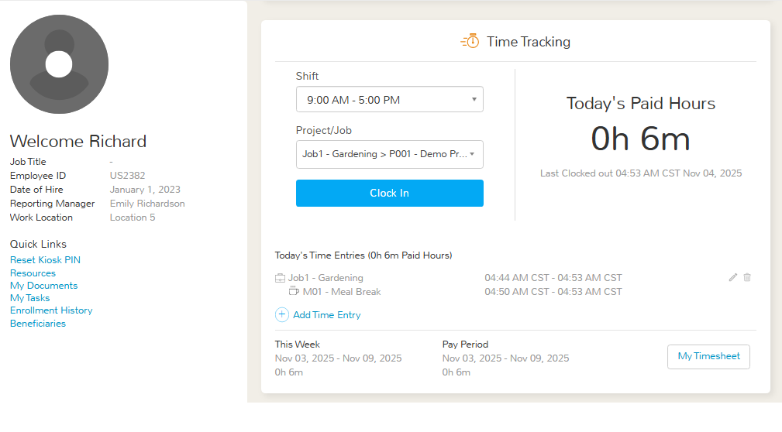
* After clock-in, a running **timer** appears on the right and shows elapsed time. Employees can click the **(+ ) Notes** icon to add context (e.g., task details, location, exceptions) to the entry for manager review and audit.

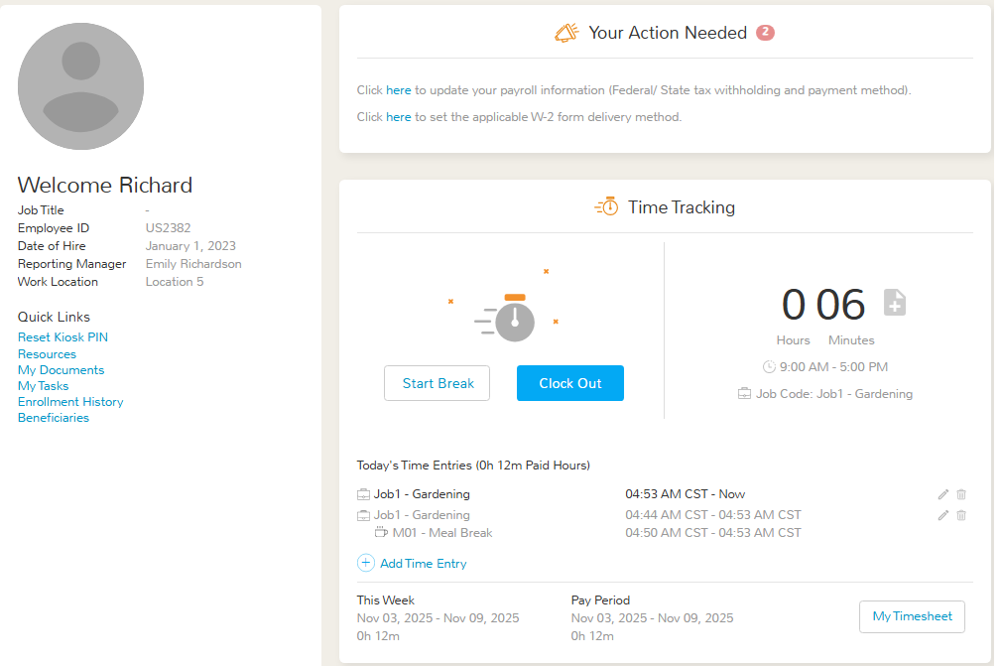

## Break In/Out-

Once clocked in, an employee can start a break by selecting Start Break.

* UZIO checks the assigned Break Rule and, if only one break type is available, begins that break immediately.
* If multiple break types are assigned (e.g., Paid Rest, Unpaid Meal), a pop-up lists all eligible options and the employee selects which break to start.
* If the Prevent Early Break guardrail is enabled and the employee tries to start the break before the eligible window, the system blocks the action and displays an error.
* While on break, a live timer on the right shows elapsed break time; employees can click the (+ ) Notes icon to add context to the entry.



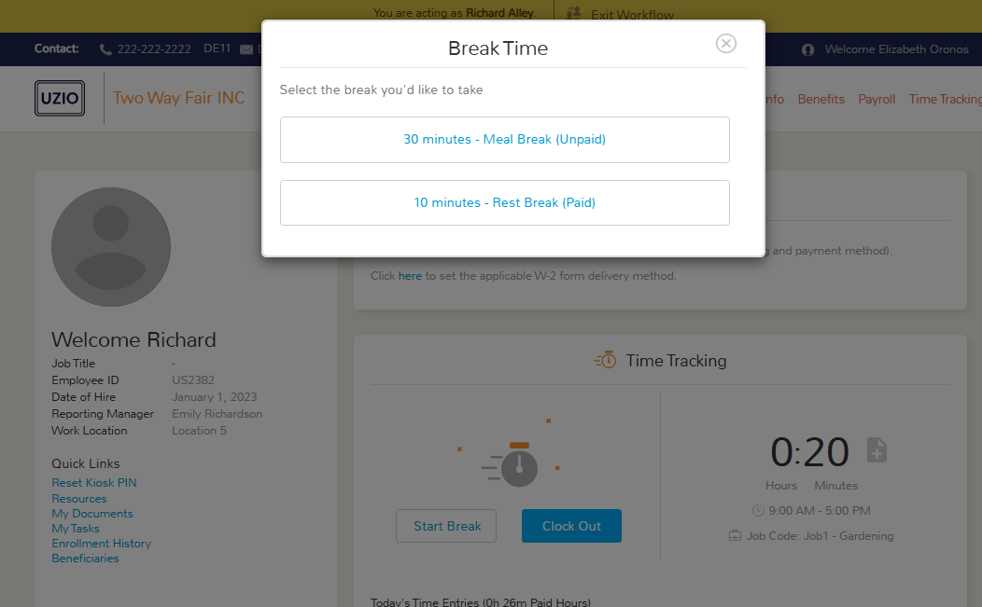

When ending a break, employees have two choices:

* End Break & Clock In — Ends the break and immediately resumes paid work time on the same entry.
* Clock Out — Ends the break and clocks out of the time entry, closing the shift.

Standard validations of preventing early end break apply. If your Break Rule includes auto-end or short/long detection UZIO applies those automatically. If break attestation is enabled and a break was not taken within the eligible window, the employee will be prompted at clock-out to acknowledge the exception.

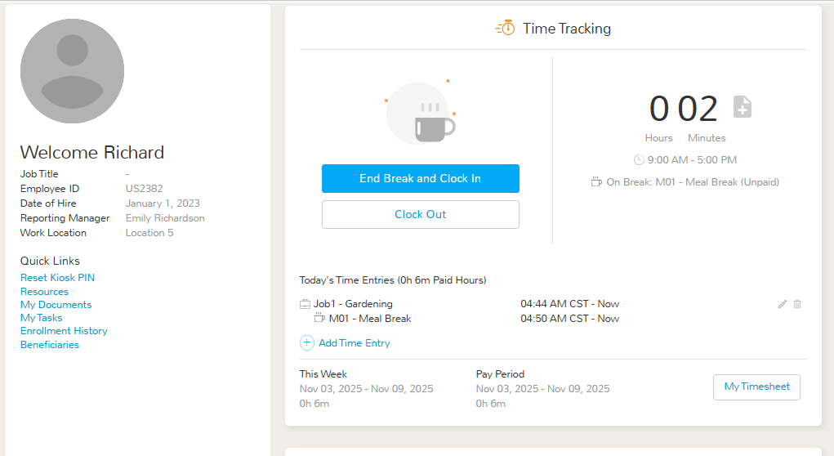

## Managing Timesheet

### Open your timesheet

From the Time Tracking tile (top-right), go to the Timesheet tab. Use the Pay Period selector to view prior or current periods; totals update automatically. Employees can view time entries for Clock In/Out, Breaks, Duration, Notes, and Status. Employees have the following actions for the time entries-

### Add time

Click Add Time Entry button to add the time entry manually by clock in/out or duration.

Edit Time Entry

Click on the Edit action to adjust time, job/shift, breaks, or duration.

### Delete Time Entry

Click on the Delete action to delete the time entry. It shows a pop up to provide the reason for the time entry deletion. It is mandatory to provide reason if the employer has mandated to provide reason while editing the time from the time tracking settings.

### Clock Out

This action only appears only when the time entry is running. Employees can clock out from the home page as well as from the timesheet page.

### Add Notes

This action allows you to add the notes in the time entry without editing it.

### History

Click the History icon to see who changed the entry, when, from which source (web/mobile/kiosk), what fields changed, old vs. new values, and any notes.

### Attest Time Entry

Click on the Attest action to attest the time entry. Confirming accuracy of a time entry.

### Check Photo

Click this action to view the photos attached with the time entry if tracked via kiosk.

### Attest All

The action is provided on the pay period level on the top of the page that attests all the time entries of the pay period that are currently not attested.

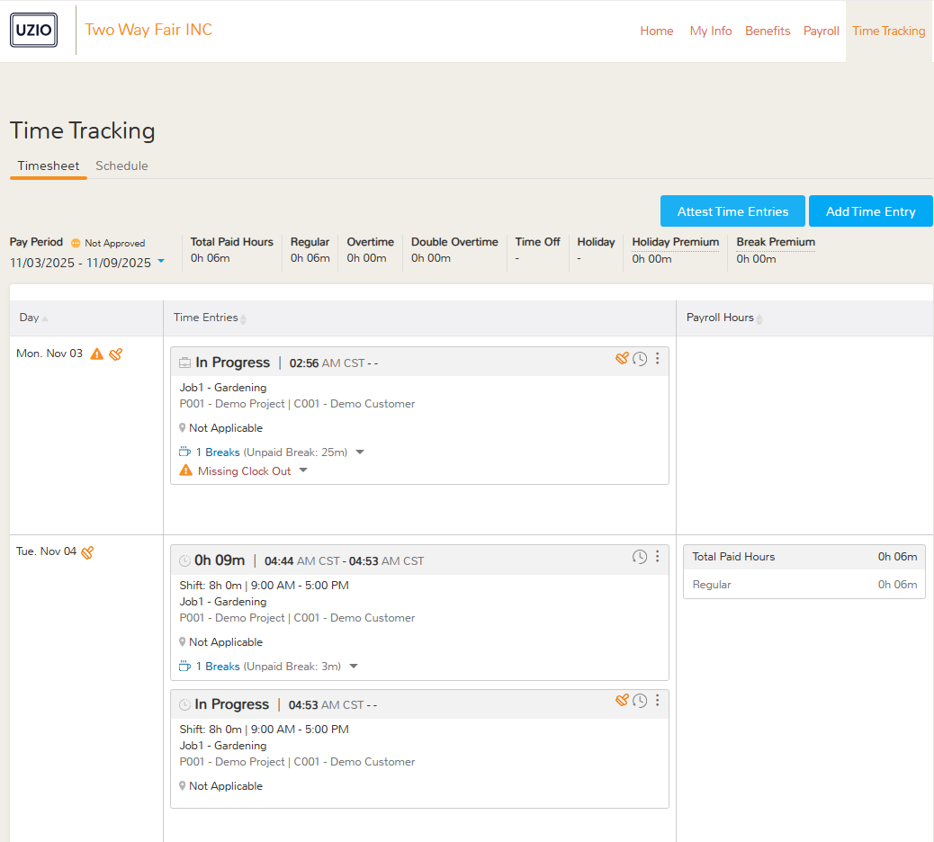

# Time Tracking on Mobile - Employee Experience

## Clock In/Out-

* Employees can track time against their **assigned shifts** and assigned jobs on the mobile app.
* On the time tracking page, if the previously selected shift and job looks good to the employee, they can directly click on the “Clock IN” button.
* Else, from the time tracking page, employees can select the “Shift” first.Once an employee selects the shift the next screen appears to select the “Job”. After selecting the job the employee gets clock into the select shift and job.
* Shift selection is **auto-preselected** to speed up clock-ins. If the current time falls within a scheduled shift, that shift is preselected. If no shift is active but another is scheduled later the same day, the **nearest upcoming** shift is preselected. If the employee has **no shift assigned** for that date, the shift selector droplist is hidden.
* The job selection is dependent on the Shift. If the selected shift has a designated job then after selecting the shift, the job selection screen does not appear and employee directly clock in to the designated job of the shift.If the shift does not have a designated job then employee can choose the job as per the assigned jobs.
* Employees can choose **Unscheduled** shifts if they’re working outside scheduled hours. Unless the employer enforces restrictions (e.g. **prevent early clock-ins**), employees may select **any** shift scheduled for that day.
* 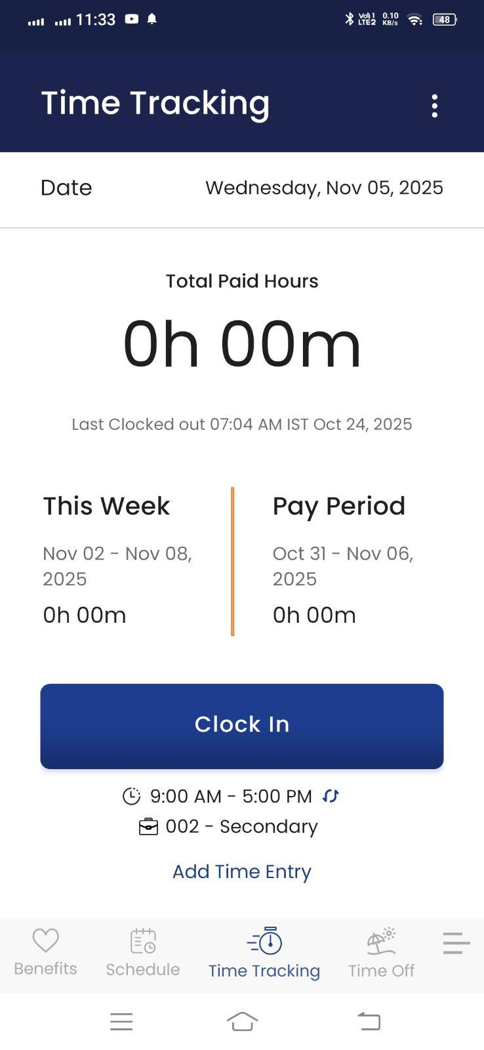 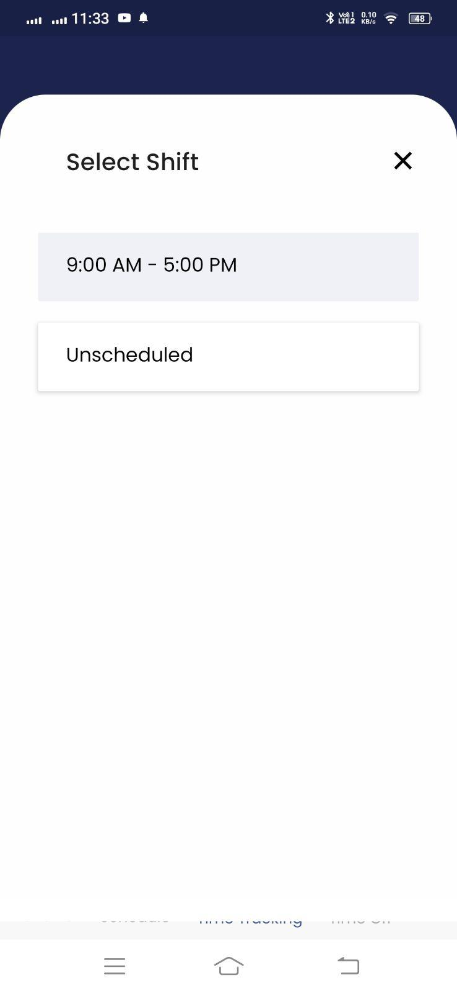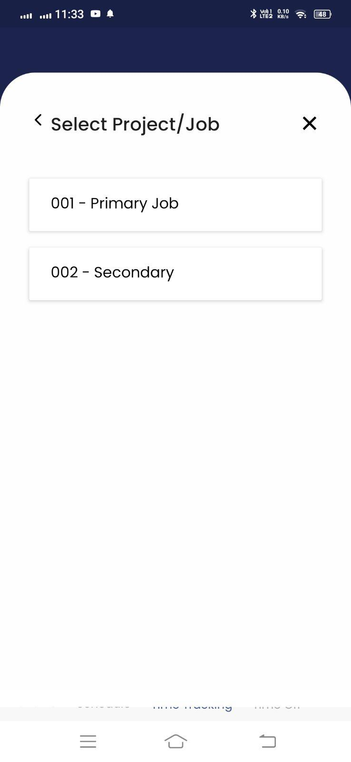
* After clock-in, a running **timer** appears and shows elapsed time. Employees can click the **Add Notes** button to add context (e.g., task details, location, exceptions) to the entry for manager review and audit.

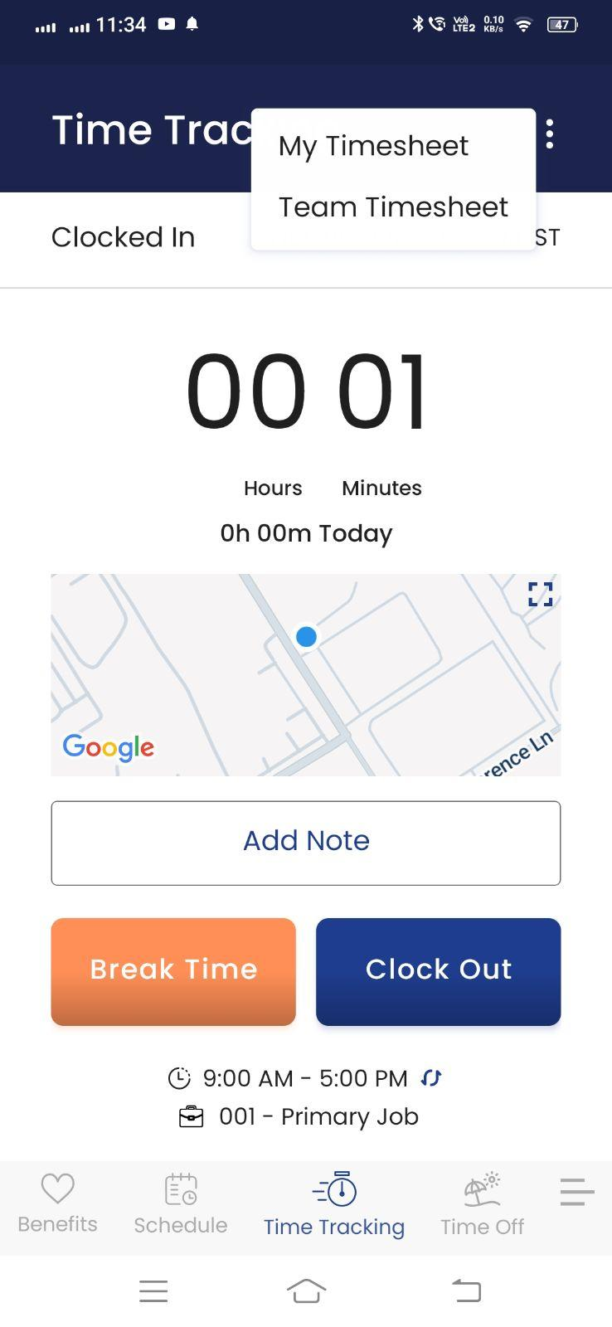

## Break In/Out-

* Once clocked in, an employee can start a break by clicking the “Break Time” button. UZIO checks the assigned Break Rule and, if only one break type is available, begins that break immediately. If multiple break types are assigned (e.g., Paid Rest, Unpaid Meal), a pop-up lists all eligible options and the employee selects which break to start.
* If the Prevent Early Break guardrail is enabled and the employee tries to start the break before the eligible window, the system blocks the action and displays an error.
* While on break, a live timer shows elapsed break time; employees can click the Add Notes button to add context to the entry.

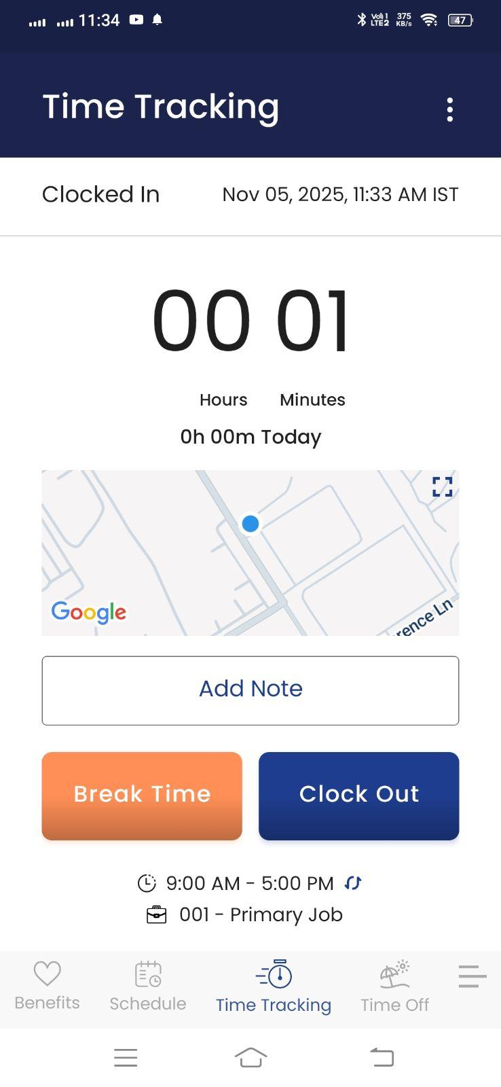 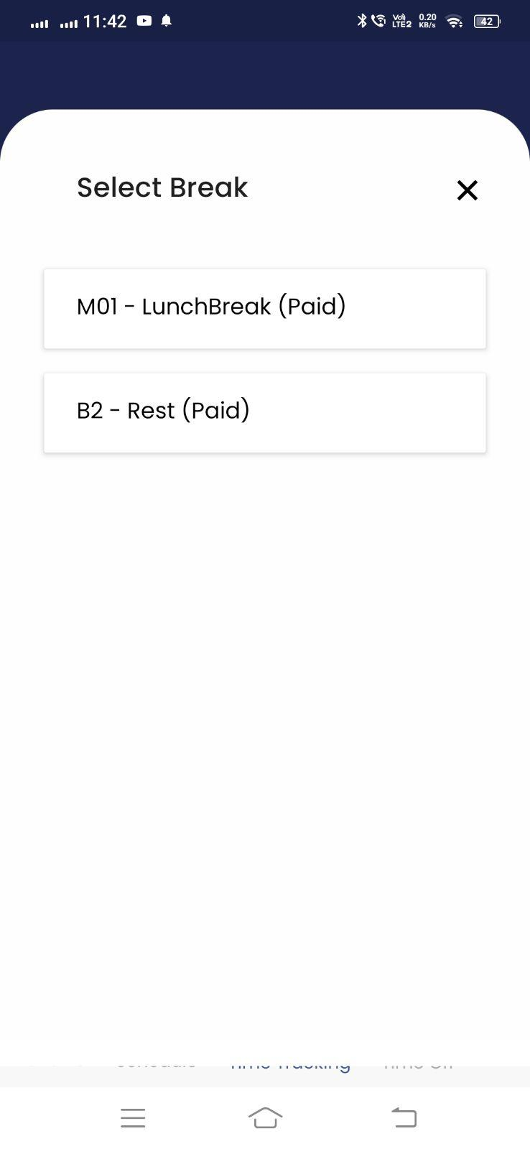

When ending a break, employees have two choices:

* End Break & Clock In — Ends the break and immediately resumes paid work time on the same entry.
* Clock Out — Ends the break and clocks out of the time entry, closing the shift.  
  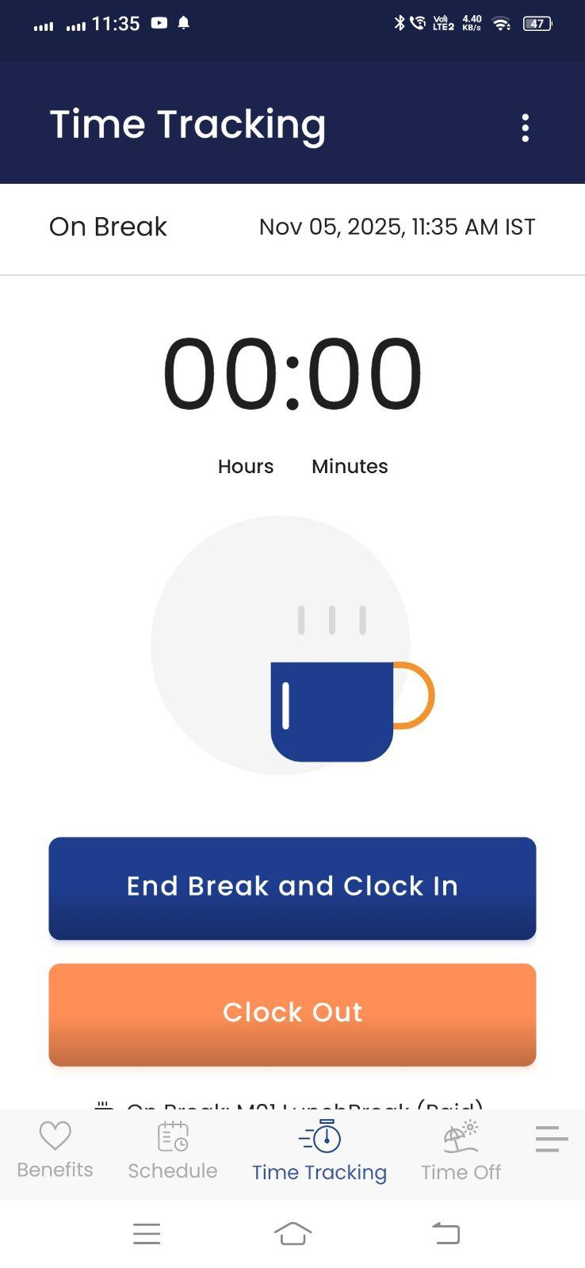

Standard validations of preventing early end break apply. If your Break Rule includes auto-end or short/long detection, UZIO applies those automatically. If break attestation is enabled and a break was not taken within the eligible window, the employee will be prompted at clock-out to acknowledge the exception.

## Managing Timesheet

### Open your timesheet

On the mobile app, employees can open their timesheet from two places. Either on the action menu on the top right corner of the time tracking page or from the hamburger menu by clicking “My Timesheet”. Employees can view time entries for Clock In/Out, Breaks, Duration, Notes, and Status. Employees have the following actions for the time entries-

 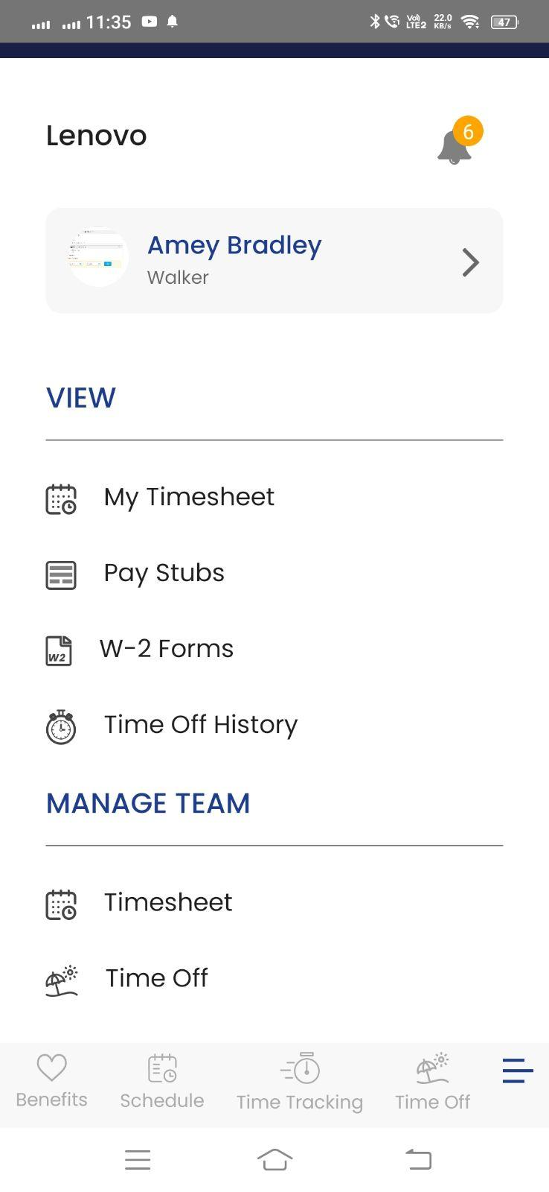

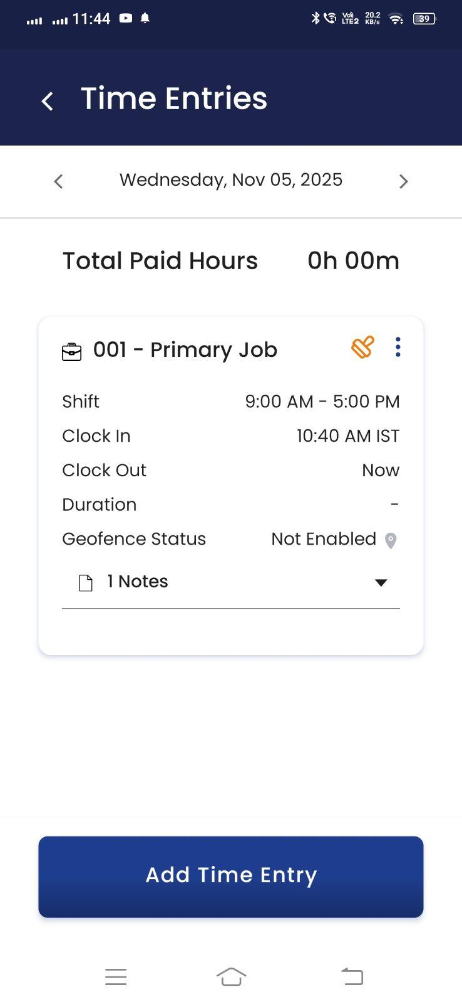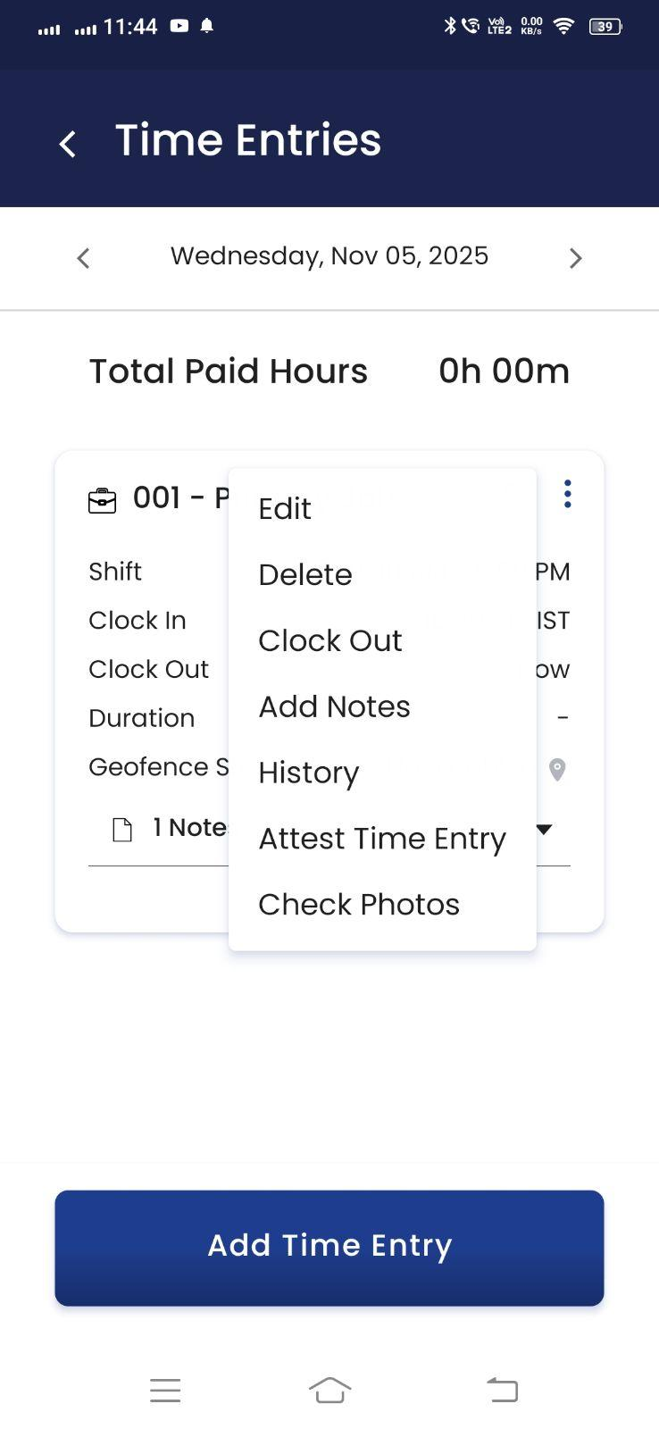

### Add Time Entry

Click Add Time Entry button to add the time entry manually by clock in/out or duration.

### Edit Time Entry

Click on the Edit action to adjust time, job/shift, breaks, or duration.

### Delete Time Entry

Click on the Delete action to delete the time entry. It shows a pop up to provide the reason for the time entry deletion. It is mandatory to provide reason if the employer has mandated to provide reason while editing the time from the time tracking settings.

### Clock Out

This action only appears only when the time entry is running. Employees can clock out from the time tracking page as well as from the my timesheet page.

### Add Notes

This action allows you to add the notes in the time entry without editing it.

### History

Click the History icon to see who changed the entry, when, from which source (web/mobile/kiosk), what fields changed, old vs. new values, and any notes.

### Attest Time Entry

Click on the Attest action to attest the time entry. Confirming accuracy of a time entry.

### Check Photo

Click this action to view the photos attached with the time entry if tracked via kiosk.

### Attest All

The action is provided on the pay period level on the top of the page that attests all the time entries of the pay period that are currently not attested.

# 

# 

# Time Tracking Employer Experience

Employers can manage employee timesheets from the employer portal. To use these feature, follow the steps below

* Login as an employer.
* Go to Time Tracking -> Employees Timesheet from the left navigation
* Here you can see the pay period droplist on the top. You can change the pay period to view the employees of the selected pay period.
* As per the selected pay period, the system shows the list of employees of the selected pay period who are added for time tracking.
* It shows grid where each row represents an employee and each column represents the following details of an employee for the pay period
  + Total Regular Hours
  + Total Overtime Hours
  + Total Double Overtime Hours
  + Total Time Off Hours
  + Total Holiday hours
  + Total Holiday Premium Hours
  + Total Premium Hours
* In front of each employee name, the system may show the icons of Notes and Exceptions, if there are any.
* Other features that are available on the page are
  + Timesheet Import
  + Hours Approval per employee
  + Hours Approval for all the employees of the pay period
  + Report Download
  + Sync Hours to Payroll

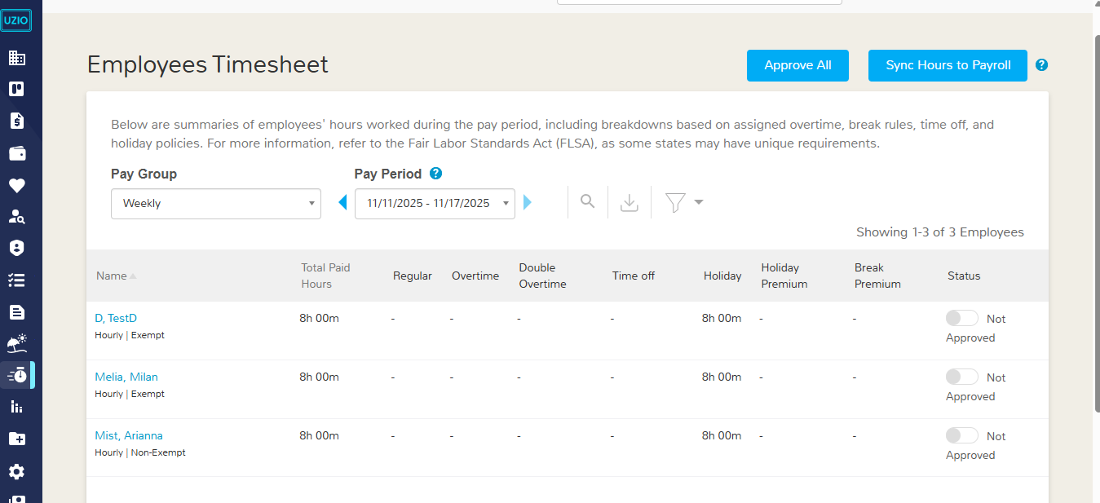

# 

# Missed Break Handling and Break Premiums calculations

## What is Missed Break

A break is considered as missed when the employee did not take it in the designated time frame.

## Missed Break Handling

To calculate the missed break of a time entry, the system uses the following two settings at the break rule level.

***Employees receive a break if they work more than ___ hours and ___ minutes***

This setting defines the first break eligibility window. These are the minimum working time an employee must complete in a shift before a break becomes due. UZIO does not prevent the employee from taking the break before the eligible window. When an employee works more than continuous *X hours Y minutes*, UZIO considers the break as eligible, if not taken, allowing the system to consider it as Missed.

**Example**If the threshold is 5 hours 0 minutes, an employee becomes eligible for the break after 5 hours of worked time. If they don’t start a break before 5 hours, UZIO can send notifications and, based on your rules, consider it like a missed break.

***Repeat break for every __ hours and ___ minutes***

This setting defines the subsequent break eligibility windows The functionality remains same as defined above.

## **What happens with a missed break**

When a break is determined as missed at clock out, the system can perform following operations as per the break configuration

### **Break Attestation by employee**

When this option is enabled at break setup, UZIO evaluates at clock-out whether the employee took the break within the eligible window. If not, the employee sees an attestation prompt. For each missed break, they can choose one of three actions:

1. Add the break to the time entry (insert the missed break per your rule) by selecting the choice **“Yes, I took this break.”**,
2. Confirm it was missed due to work by selecting **“No, I was prevented by work from taking this break.”**
3. Confirm it was missed by choice by selecting **“I had the opportunity, but I freely chose not to take this break.”**

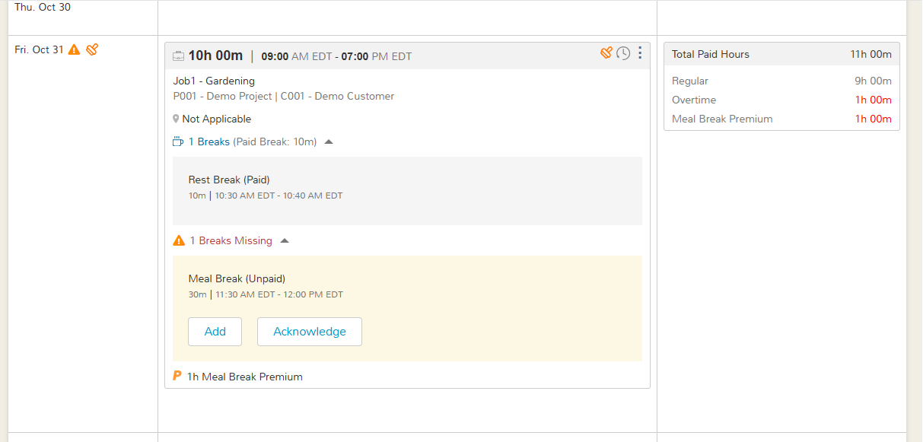

### Flag as Missed Break-

If a break is configured to be handled without attestation, UZIO automatically marks it as “Missed” on the time entry. The flag is placed at the position you set under the “**Deduct/Flag Missing Break at**” setting in the break setup. No prompt is shown to the employee; the entry is simply flagged for review, and any configured premiums are applied

### **Auto Deduct**

If a break is configured to be auto-deducted, UZIO automatically inserts the break into the time entry according to the break rule. The insertion occurs at the configured position/time and adjusts worked totals and payroll (paid vs. unpaid) accordingly—no employee action is required.

## **Position of Missed Break or Auto Deducted break**

System place or flag the missed-break inside the time entry when a break isn’t taken within the eligible window.

* + Starting of Time Entry — Places or flags the missed break at the start time of the eligible window. Example- If the eligible window of the break is 9AM to 2PM and the break duration is 30 Minutes, the missed break will be placed or flagged from 9AM to 9:30 AM.
  + Middle of Time Entry — Places or flags the missed break at the midpoint of the eligible window. Example- If the eligible window of the break is 9AM to 2PM and the break duration is 30 Minutes, the missed break will be placed or flagged from 11:30AM to 12:00 AM.
  + End of Time Entry — Places or flags the missed break at end of the eligible window.Example- If the eligible window of the break is 9AM to 2PM and the break duration is 30 Minutes, the missed break will be placed or flagged from 1:30PM to 2:00 PM.
  + Custom Hours — Flags the missed break at a specific offset from the start (e.g., at 1 hour). Use this when policy requires the missed break to be recorded at a specific time. Example- If the eligible window of the break is 9AM to 2PM and the break duration is 30 Minutes and the custom time defined in this setting is 1 Hour, the missed break will be placed or flagged from 10 AM to 10:30 AM.

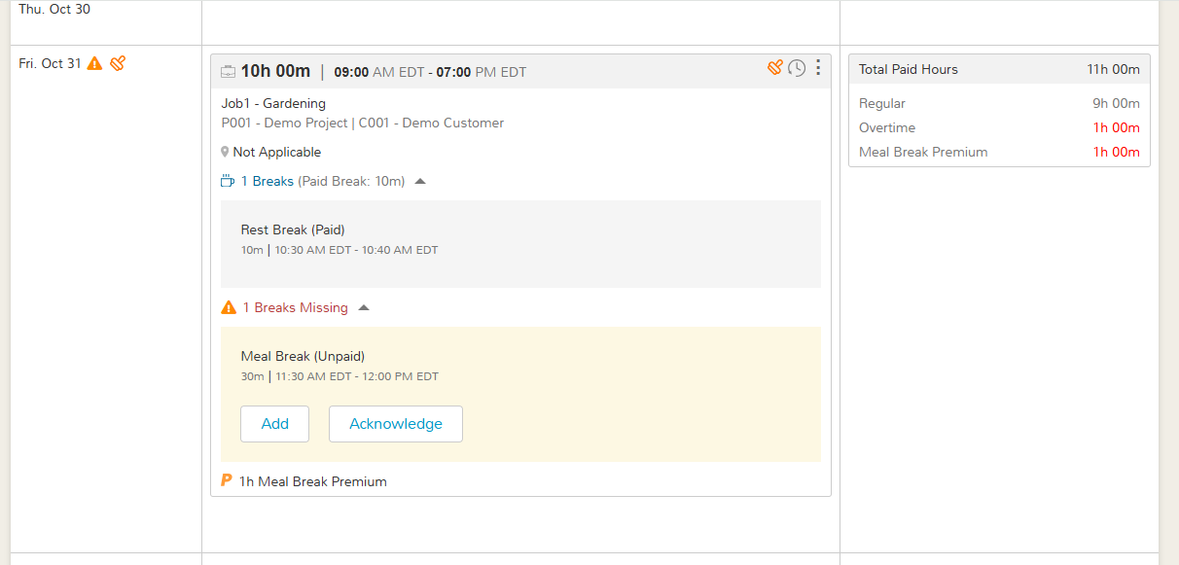

## **Adding Missing Breaks by Manager**

If an employee misses a break, the time entry shows a **Breaks Missing** section. A manager can add those breaks back into the record by following below steps

* Open **Employees Timesheet** from the left navigation
* Locate the entry and expand **Breaks Missing** section
* Select **Add Missing Breaks** button

This opens the **Edit Time Entry** pop-up with the missed breaks already pre-filled and highlighted with an orange dot to distinguish them from taken breaks. The manager can adjust break times or premiums as needed and then save. Standard validations apply (no overlaps; breaks must fall within the entry), and the update is captured in the audit trail.

When you save changes, UZIO recalculates break premiums based on the breaks actually taken and any breaks that are now considered missed/short under the assigned Break Rule. The system then compares the newly calculated premium with the previously applied premium on the entry and lets you choose which one to keep—Use Newly Calculated or Keep Existing. This gives employer users flexibility to override premiums when justified (e.g., manager-approved exceptions) or to apply policy as configured when recalculation is correct.

All updates—including premium selections—are recorded in the audit trail with who made the change, when, and any required notes, ensuring transparency for reviews and payroll.

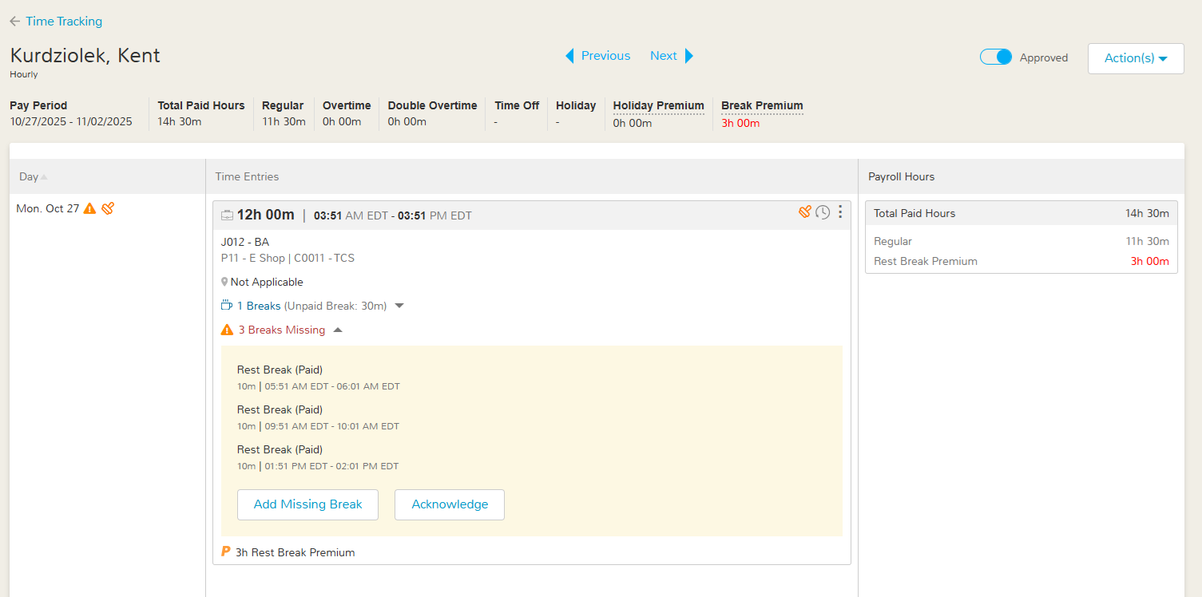

## **Acknowledging Missed breaks by Manager**

If an employee misses a break, the time entry displays a Breaks Missing section. A manager can acknowledge these items by following the below steps

* Open **Employees Timesheet** from the left navigation
* Locate the entry and expand **Breaks Missing** section
* Select **Acknowledge** button

Acknowledging confirms that the employer accepts the missed break for that shift. After acknowledgment, the missed-break record is cleared from the entry view, but any associated premium remains applied as configured. The acknowledgment, including who performed it and when, is recorded in the audit trail.

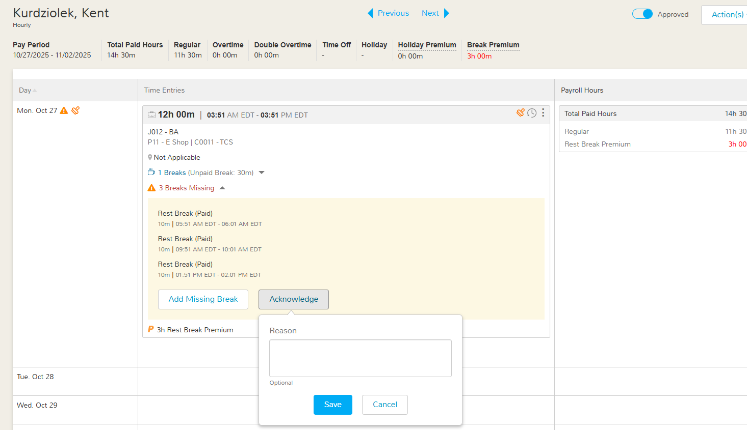

## **Break Premium Calculation**

### **Short Break Premium**

If your break rule setup includes a short-break premium, UZIO will calculate and apply it automatically when a break ends too early. A break is flagged as Short when the employee ends it before the scheduled end time (start + duration) minus the early-end variance you set. When that condition is met, UZIO flags the break as Short and adds the configured premium to the time entry and payroll totals.

Example: Break starts at 9:30 AM, duration 30 minutes (scheduled end 10:00 AM), variance 10 minutes. If the employee ends the break before 9:50 AM, the system flags it as a Short Break.

### **Missed Break Premium**

If your break rule setup includes a missed-break premium, UZIO will calculate and add the premium automatically whenever a break is missed. The premium amount (hours/minutes) is applied per missed break and reflected in payroll totals.

### **Break Premium Capping**

UZIO automatically adds premium paid time to the time entry when a break is missed or short, as defined in your break rule. A cap of 1 hour applies to the total premium per break category, per time entry.

Example: If the premium is 1hour per violation and two breaks are missed in the same entry, the calculated premium would be 2 hours. Because the category cap is 1 hour, the final premium applied is 1hour. The capped premium is reflected in payroll totals.

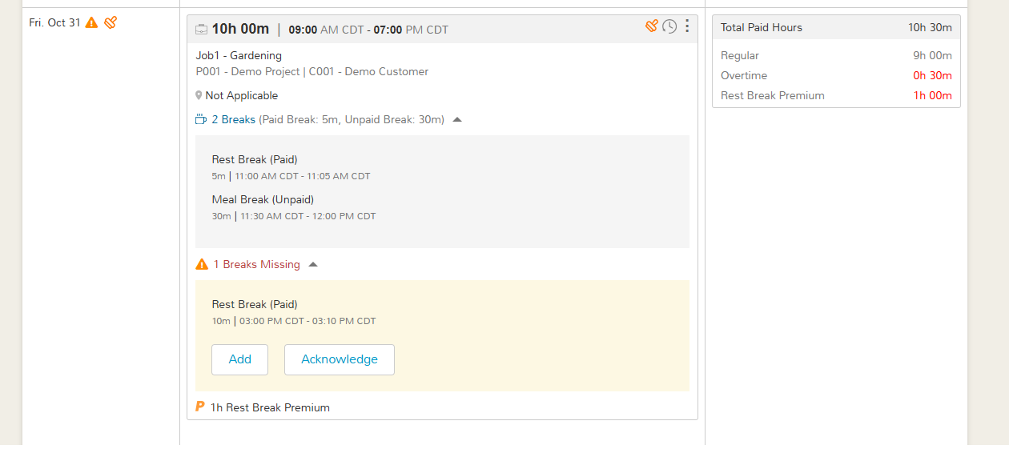

# Time Entry Exceptions

There are multiple exceptions in the time entry. If a time entry has exceptions, the system shows an icon with the time entry to reflect. The same icon is available on the pay period to represent any time entry has an exception. A few exceptions, restrict the approval of hours as well. Below is the list of exceptions-

## **Missing Clock Out**

A long running time entry which is flagged as Missing Clock Out.

## **Running Time Entry**

A time entry which is currently running. It restricts the approval of hours.

## **Manager Approval Pending for Manually Added Time entry**

Employee manually added a time entry which is pending for manager approval. It restricts the approval of hours.

## **Manager Approval Pending for Manually Edited Time entry**

Employee manually edited a time entry which is pending for manager approval. It restricts the approval of hours.

## **Missed Breaks**

An eligible break not taken in the eligible window. Timesheet hours are not restricted to be approved due to this exception.

## **Short Breaks**

A break ended early from its scheduled duration.Timesheet hours are not restricted to be approved due to this exception.

## **Long Breaks**

A break ended late from its scheduled duration.Timesheet hours are not restricted to be approved due to this exception.

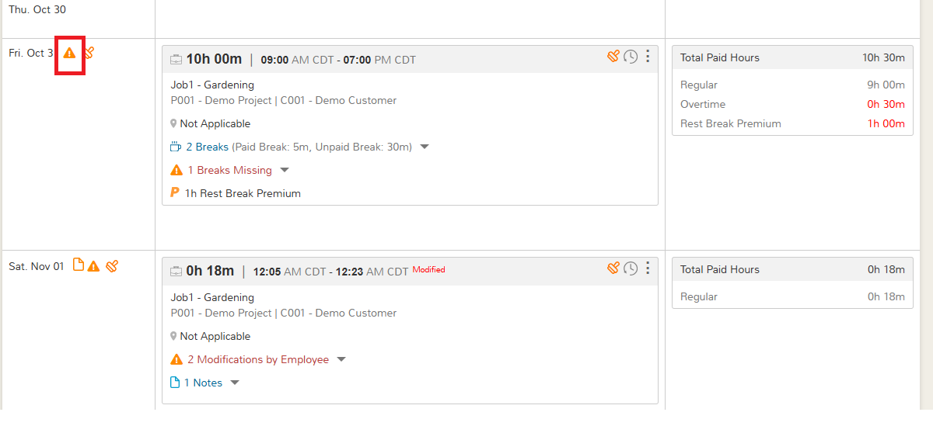

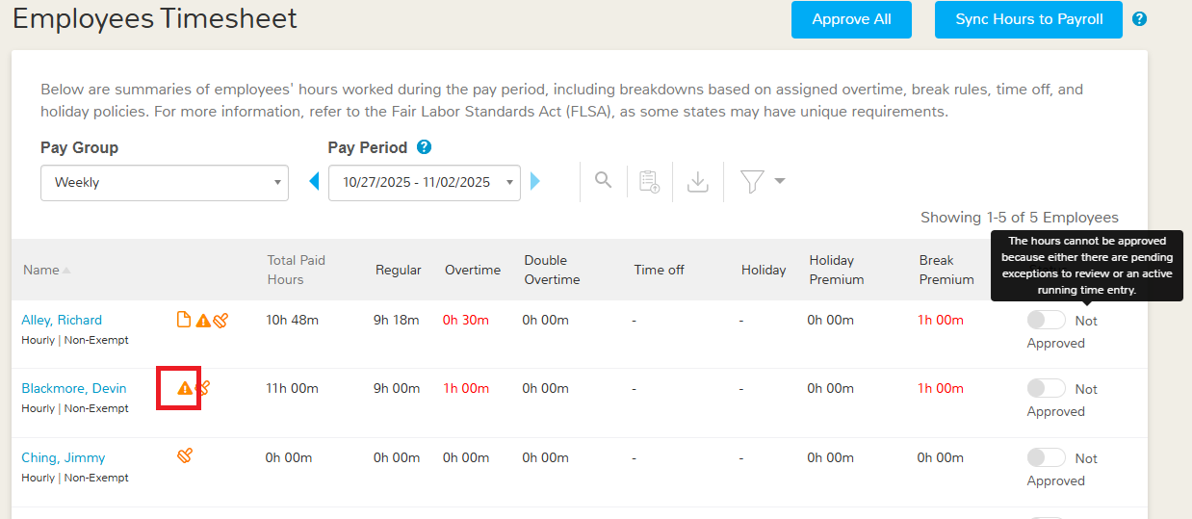

# Timesheet Approval and Payroll Syncing

## Timesheet Approval

Employer users with permission to manage employees’ timesheets can approve them. To approve the timesheet follow the steps below

* Log in as an Employer.
* Open **Employees Timesheet** from the left navigation menu.
* Select the appropriate **pay period** for which you are about to approve the hours.
* You can either approve a single employee by toggling the **Status** switch in their row
* Also, you can approve everyone at once with the **Approve All** button.
* Also, you can click on the employee’s name to see the detailed information of the employee's timesheet and can approve all the time entries on the next screen.

Once approved, employees can no longer edit their own entries, though managers with the right permissions can still make corrections.

Approval may be blocked if there is a Missing Clock-Out, a Running Time Entry, or any Manager Approval Pending item for manually added/edited entries; resolve these first, then approve.

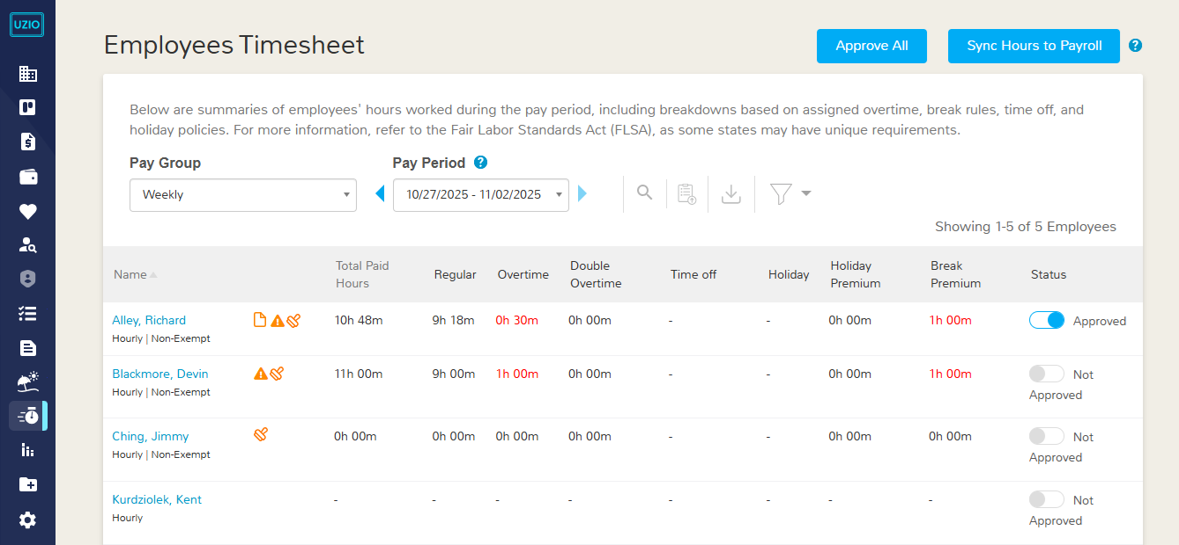

## Syncing Hours to Payroll

After a timesheet is approved, the manager’s next step is to sync hours to payroll. Until hours are synced, they won’t flow into payroll processing and will not appear on employee paychecks. This step finalizes the approved totals for payroll—un-synced hours are effectively invisible to payroll.

To sync the hours to payroll, follow the steps

* Log in as an Employer Admin
* Open the Employees Timesheet from the Left Navigation
* Select the appropriate **pay period** for which you are about to sync the hours.
* Review the approval status, and click **Sync Hours to Payroll** button.

Once the hours are synced to payroll, the employer as well as manager both can’t make changes to the employee timesheet. If employers want to make changes, they should first un-sync the hours, make the required changes and then approve and sync the hours again to reflect in the payroll processing.



# Time Entry History

UZIO maintains a comprehensive, immutable audit trail for every time entry. Each change—whether initiated by an employee, manager, or via import—creates a discrete log record that can be reviewed for compliance, payroll reconciliation, and dispute resolution. The audit trail is read-only and preserves the full context of what changed, who changed it, when, from where, and why.

To allow employees to review their own time history

* Log in as an Employer Admin
* Open Time Tracking Settings → Time Clocks from the left navigation
* Enable **Show time history to employees**.

Once enabled, employees can open the history from the Time History icon on the web timesheet or by tapping History in the mobile app. Managers always retain access through the managerial view for coaching and approvals.

Each audit record includes following information

* Timestamp (date/time of the event)
* Changed By (name of employee, manager, or system)
* Source (web, mobile, kiosk, upload/API)
* Action Performed (Detailed below)
* Field Name (Detailed below)
* Old Value of field
* New Value of field
* Notes/Reason (if required)
* IP Address

These fields make it possible to reconstruct the exact sequence of events for any entry.

**Supported actions** captured in the log include operational events (Clock In, Clock Out, Break In, Break Out), manual maintenance (Add, Edit, Delete), and managerial controls (Approve, Manager Edit/Delete). Policy- and compliance-related events are also recorded, such as Missed Break Added, Missed Break Acknowledged, Note Added/Acknowledged, Time Entry Attested, Hours Synced to Payroll, and Timesheet Upload.

**For field-level visibility**, UZIO records changes to Clock In/Out Time, Date, Duration, Shift, Job, Break, Rest/Meal Premiums, Manager Acceptance Status, Payroll Hours Status (e.g., synced/not synced), Notes, and Time Attestation Status.

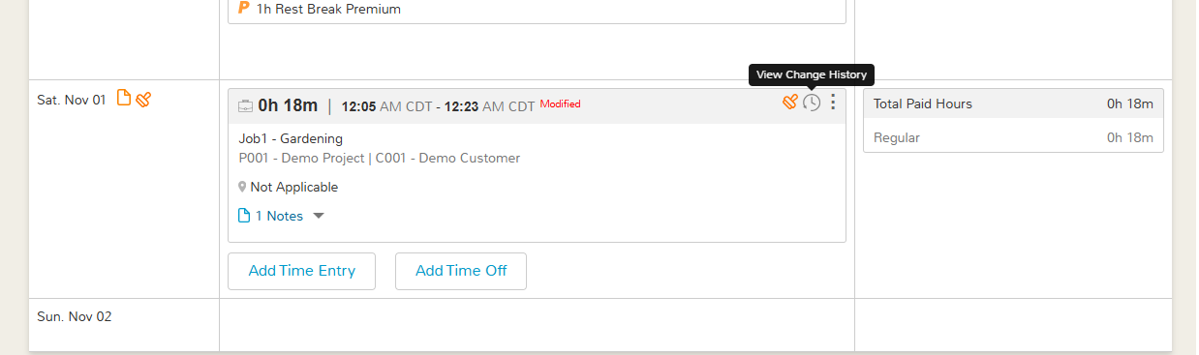

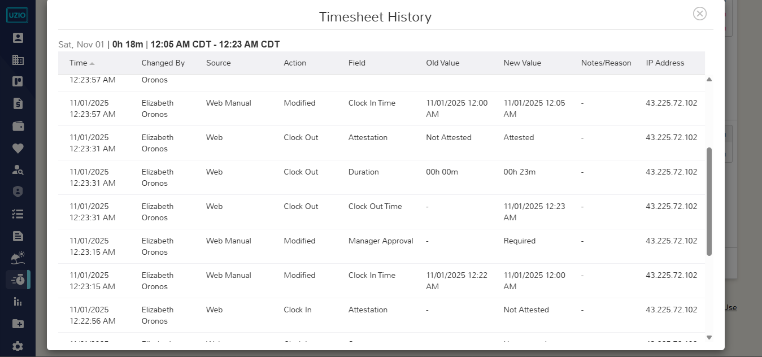

# Reports

UZIO Time Tracking provides clean, auditable records of work time and breaks, with rules for overtime, premiums, and approvals. Standard reports include Time Entries, Daily Hours Worked, and Payroll Hours Summary, giving managers visibility from granular edits to payroll-ready totals.Data can be reviewed online and exported, supporting compliance reviews, exceptions management, and accurate payroll processing.

## **Time Entries Report**

Shows a date-wise list of each employee’s clock-in/clock-out activity, worked durations, and any missing clock-out flags, with indicators for punches made inside or outside the geofence.

Along with the employee’s demographic information, the report contains the following columns

* **Shift Start Time-** The start time of the selected shift.
* **Shift End Time-** The end time of the selected shift.
* **Job**- The selected job of the time entry.
* **Break-** The taken breaks of the time entry.
* **Missed Break-** The missed breaks of the time entry.
* **Project-** The project of the selected job of the time entry.
* **Customer-** The customer of the selected job of the time entry.
* **Clock In**- The actual clock in time of the time entry.
* **Clock Out**- The actual clock out time of the time entry.
* **Total Duration**- The total duration of the time entry.
* **Paid Work Hours-** The total paid work hours of the time excluding paid breaks.
* **Paid Break Hours-** The total hours of the taken paid breaks.
* **Unpaid Break Hours-**The total hours of the taken unpaid breaks.
* **Missed Meal Break-** The total hours of missed meal break.
* **Meal Break Premium-**The meal break premium in the time entry.
* **Missed Rest Break-** The total hours of missed rest break.
* **Rest Break Premium-** The rest break premium in the time entry.
* **Timezone-** Timezone of the time entry.
* **Notes/Reason**
* **Geofence**
* **Source**

## **Daily Hours Worked Report**

Provides a day-by-day breakdown of regular, overtime, double-time, and holiday hours for the selected period, enabling quick review of daily totals and exceptions.

Along with the employee’s demographic information, the report contains the following columns

* Regular Hours
* Overtime Hours
* Double Overtime Hours
* Holiday Premium Hours
* Total Hours Worked

## **Payroll Hours Summary Report**

This report gives the summary of total hours, overtime hours, double overtime hours, missed meal break hours, and missed rest break hours for the exempted or non-exempted employees on salaried or hourly wages along with their approval status from the respective managers.

Along with the employee’s demographic information, the report contains the following columns

* Regular Hours
* Overtime Hours
* Double Overtime Hour
* Meal Break Premium hours
* Rest Break Premium hours
* Paid Time Off
* Holiday Hours
* Holiday Premium hours
* Total Hours

# Administrative Tools

## Bulk Import Time Entries

Use Bulk Upload to import clock-ins/outs and breaks from another system so you can process payroll in UZIO without re-keying. The upload consumes a standard template and creates entries sequentially.

To start timesheet upload

* Go to Employees Timesheet from the navigation menu
* Click the “Time Entries Import” icon.
* When prompted, download the template.
* Populate the file with these columns: Employee ID, Employee Name, Entry Date, Job code, break code, Clock In, Clock Out, timezone, duration and Notes. Use the formats shown in the template (date/time).

A row may represent either a main entry, meaning the start and end time of the entry which may contain breaks inside or, a break itself. Fill the break code column only for the rows reflecting a break. Leave the break code column blank on the main entry row.

### Mandatory row order

UZIO processes rows in order. Always list the parent (main) time entry first, followed immediately by its break rows. This is required so the system creates the shift before attaching its breaks.  
 Example (correct):

1. Parent: 2025-11-03, 09:00–17:00
2. Break: 12:30–13:00  
    If a break row appears before its parent, that break will fail validation or won’t link to the correct entry.

**Upload the file-** After you complete and order the rows, return to **“Time Entries Import”**, choose the file, and submit. UZIO will import each row one by one, building the day’s timeline for each employee from the parent entry and then inserting the associated breaks.

**Validations & common checks-**  The system verifies required fields, date/time format, employee identity, and logical sequences (Clock In < Clock Out, Break In/Out within the parent, overlaps, etc.). It also checks for duplicates and missing parents for listed breaks.

**Error handling-**  If any row fails, UZIO generates an error file in the File Center. Download it to see the row number and a clear error message. Fix the file, preserve the required row order, and re-upload.

**After a successful upload-**  Imported entries appear on the Timesheet grid and follow your existing rules (overtime, premiums, approvals). Managers can review, approve, and—when ready—Sync Hours to Payroll so hours flow into pay calculations.

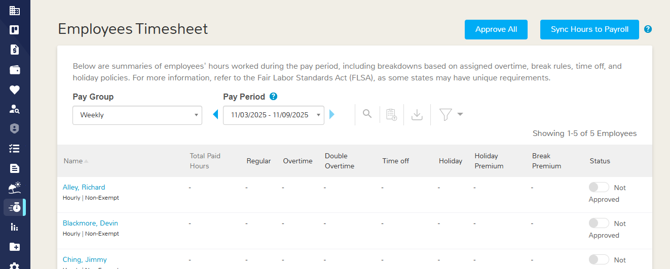

# Manual Modifications in the Time Entries and approval

Manual changes to time entries (add, edit, delete) and timesheet approvals can be performed by Employer users who have Full Access to Employees Timesheet on their role.

Employee users may modify their own entries only when the setting “Allow employees to add, edit and delete their time entries” is enabled; otherwise, they can view but must request a manager to make corrections. All actions follow role permissions and are recorded in the audit trail.

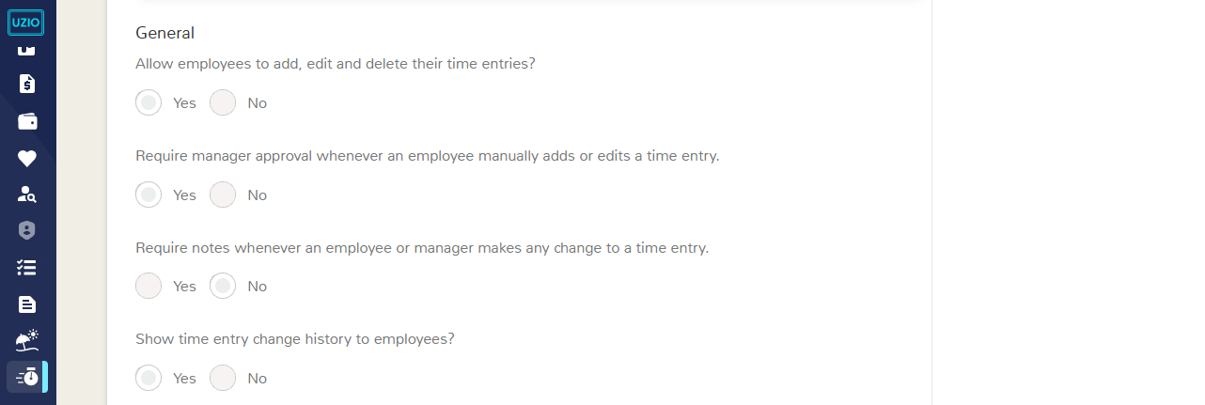

## Adding a Time Entry

To add a time entry

* Open the Timesheet page
* Click “Add Time Entry”.
* A pop-up lets you choose how to enter time: Clock In/Out (enter exact start and end times, and breaks if known) or By Duration (enter the total hours/minutes when exact punches aren’t available).
* Use Clock In/Out if you know the precise punch times; use By Duration for estimated work blocks or after-the-fact corrections.
* Provide any required notes and save. If your policy requires it, an employee’s manually added entry will be routed to the manager for approval before it posts to the timesheet.

When you add a time entry, UZIO runs validations to ensure the record is logical and consistent. The system prevents common errors such as overlapping punches or breaks and breaks that don’t fit within the entry.

* A time entry **cannot overlap** with another time entry for the same employee.
* A break **cannot overlap** with another break.
* A break **must occur within** its parent time entry (it can’t start before clock-in or end after clock-out).
* The **total break duration** cannot exceed the **time entry duration**.
* The **sum of all break durations** within an entry cannot exceed **24 hours** (hard cap).
* Restricting to add a future dated time entry.

If any rule is violated, the entry is blocked and an error message explains what to fix.

### Adding time entry by Clock In/Out

* **Date & Time:** Enter the date, Clock In, and Clock Out for the time entry.
* **Job:** Select the Job/Assignment the employee worked under.
* **Shift (optional):** Choose the Shift if one is assigned for that date.
* **Breaks (optional)**: Click Add Break to manually record any Break In/Out times.
* **Apply Break Rule (optional):** Check this to let UZIO evaluate the entry against the assigned Break Rule—eligible breaks are inserted automatically; missed/late/short breaks are flagged and any configured premiums are applied.
* **Notes (recommended):** Add a brief reason/context for audit and approvals

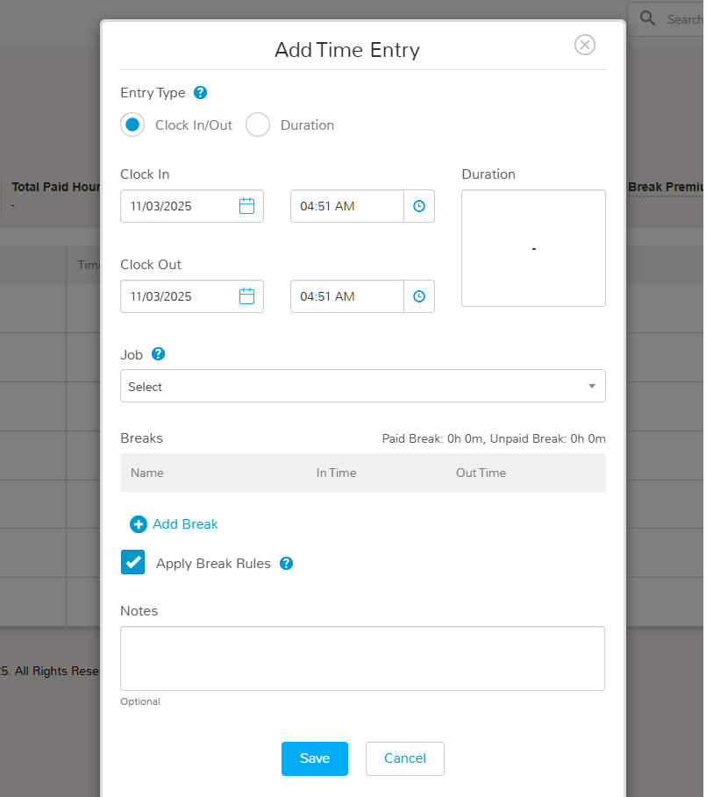

### Adding time entry by Duration

* **Date & Duration:** Enter the date and the total duration (hours/minutes) for the time entry.
* **Job:** Select the Job/Assignment the employee worked under.
* **Shift (optional):** Choose the Shift if one is assigned for that date.
* **Breaks (optional):** Click Add Break to record any breaks taken so the entry reflects accurate worked time.
* **Notes (recommended):** Add a brief reason/context for audit and approvals.

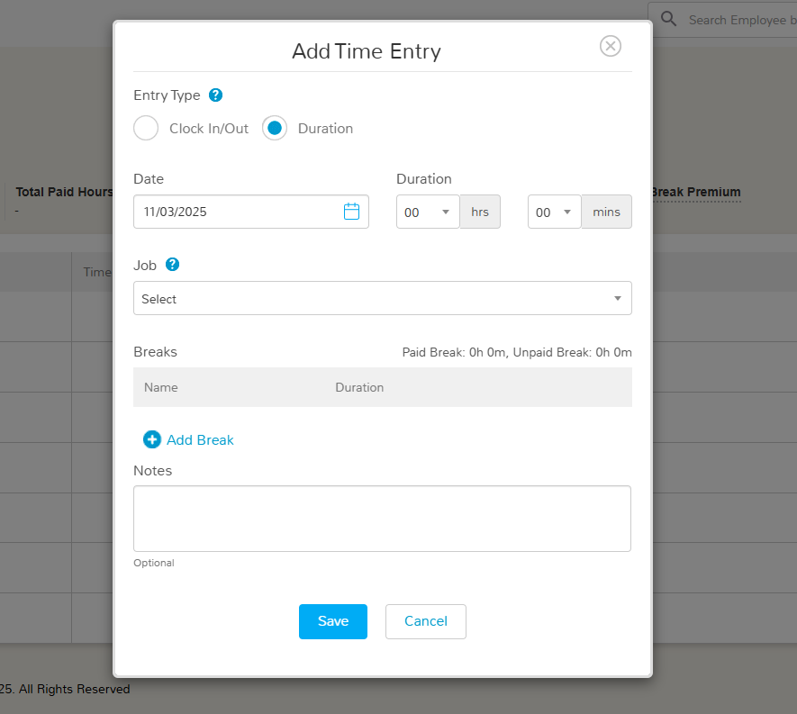

## Editing a Time Entry

* To make the modifications in the time entry, you can edit it. To edit a time entry, Open the Timesheet page
* Choose Edit on the relevant row, and update the fields in the pop-up.
* You can adjust Clock In/Out times, Shift, Job/Assignment, Duration, and Break In/Out times; you may also add or delete breaks and update any break premiums. Standard validations apply (no overlaps, breaks must sit within the entry, etc.), and an error will explain any issue that needs correction.
* You cannot adjust the time entry date as well as its type (Clock In/Out vs Duration)

When you save changes, UZIO recalculates break premiums based on the breaks actually taken and any breaks that are now considered missed/short under the assigned Break Rule. The system then compares the newly calculated premium with the previously applied premium on the entry and lets you choose which one to keep—Use Newly Calculated or Keep Existing. This gives employer users flexibility to override premiums when justified (e.g., manager-approved exceptions) or to apply policy as configured when recalculation is correct.

All updates—including premium selections—are recorded in the audit trail with who made the change, when, and any required notes, ensuring transparency for reviews and payroll.

An employee cannot edit a time entry once the manager has approved the time hours and a manager cannot edit the time entry once the hours are synced to payroll.

Once an entry is edited, the payroll hours are automatically updated as per the new records.

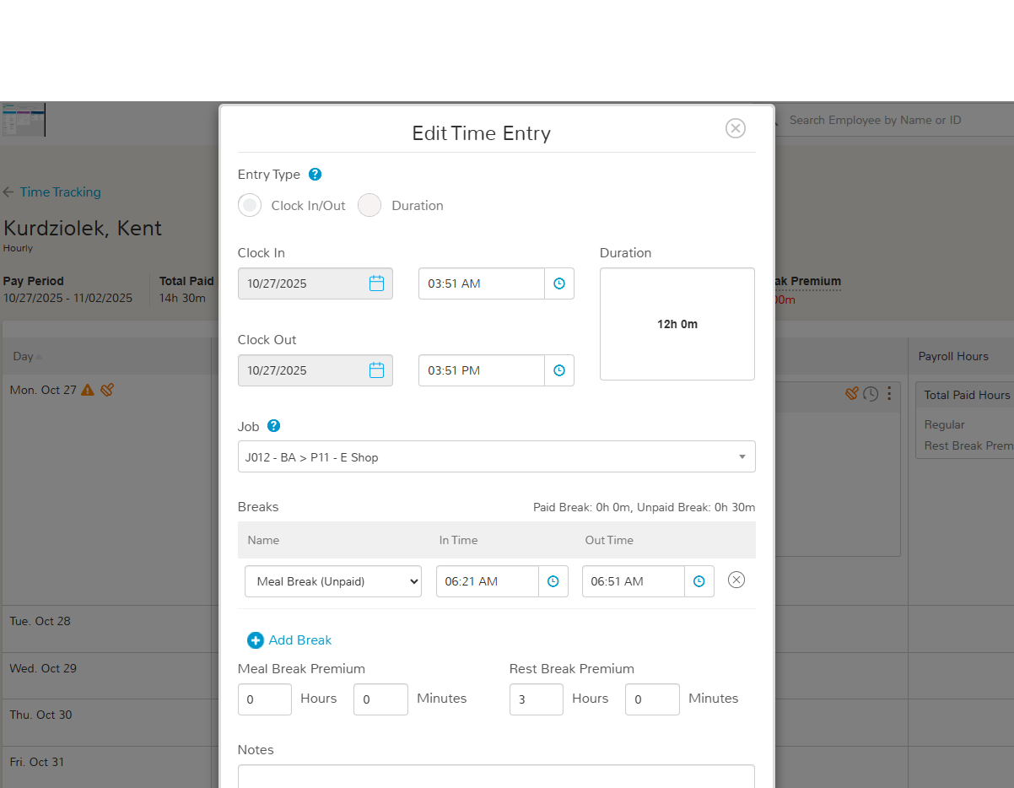

## Deleting a Time Entry

To delete a time entry, open the **Timesheet** page, click **Delete** on the relevant row, and confirm in the pop-up. Deletion is **permanent**—the entry cannot be restored and will no longer appear on the timesheet or related views. Any attached breaks and premiums are removed with the entry. 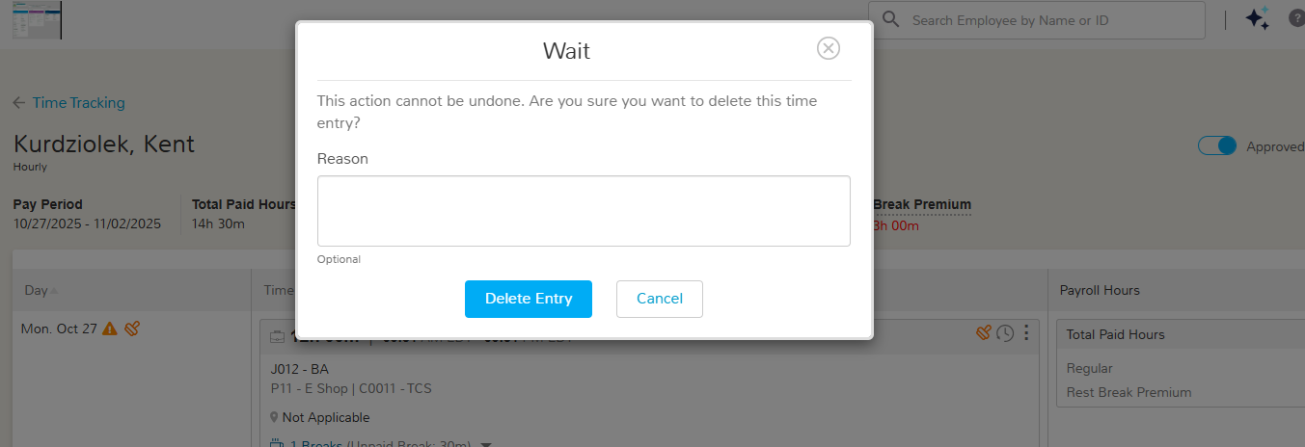

## **Manager approval for Employee Modifications**

Enable manager sign-off on employee changes by turning on “*Require manager approval whenever an employee manually adds or edits a time entry*” in Time Tracking Settings → Time Clocks. When enabled, any employee add/edit is routed to the manager for approval before it is applied to the timesheet.



Managers can view the old and new values of the edited time entries and can approve. If the managers do not want to approve, then they can edit the time entry and can revert the changes manually. Managers can perform the same action on the web as well as on mobile applications.

Also, till the time manager’s approval is pending the time hours cannot be approved.

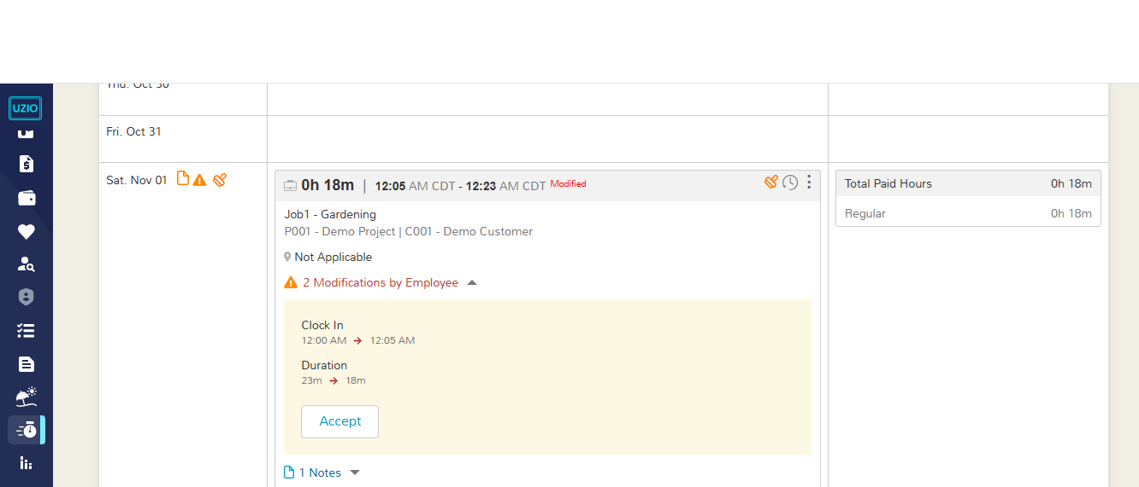

# Time Attestation

Time attestation asks employees to confirm the accuracy of their hours—and, when applicable, whether they had a fair opportunity to take required breaks. It strengthens compliance, reduces disputes, and creates a clear record for audits and payroll.

## Configuration

* **Enable Time Entry Attestation:** *Time Tracking Settings → Time Clocks* -> Require Employee Attestation for time entries?
* **Enable Break Attestation:** In the relevant **Break Rule → Resolving Missed Breaks** -> **Break Attestation Required?**

Both types of attestation appear on the same screen in UZIO. Attestation prompts are shown at **clock-out** on the web, mobile, or kiosk—based on how you configure the policy. Employees review their day and respond before the entry is saved.

## Time Attestation by Employees

* Employee taps **Clock Out**.
* UZIO checks for required attestation and shows on the same screen-  
  + If a **missed** **break exception** exists and break attestation is enabled at break setup level, the employee answers the missed-break question(s) and may add a note.
  + If **time attestation** is enabled, the employee confirms day-level accuracy.
    - It includes Clock In Time, Clock Out Time, All breaks taken, Shift (If selected) and Assigned job.
* The entry is saved, and the attestation is written to the **audit trail**.
* UZIO logs the full context in the **audit trail**: who attested, timestamp, source (web, mobile, kiosk), and the related entry identifiers. For break attestation, UZIO also records whether the break was **added**, **missed due to work**, or **missed by choice**, and applies any configured **premiums** or **flags**.

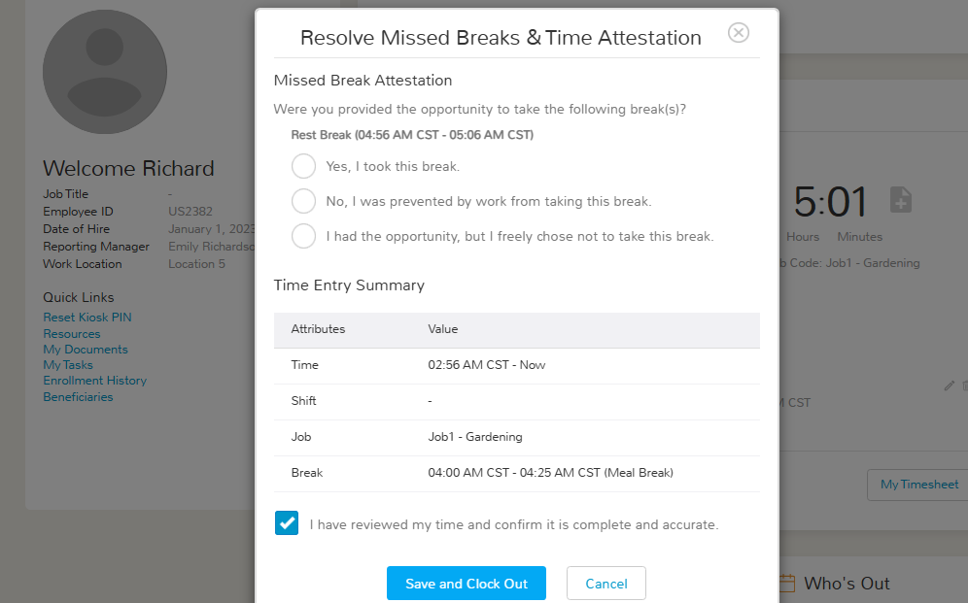

## Missed Time Attestation Notification

The employer can configure if they want to send the notifications to employees for their not attested time entries. They can configure this from the Time Tracking Settings -> Time Clocks ->

The employer can choose the channel of notification by selecting Email/SMS/Push notification. The UZIO sends two notifications

#### Daily Notification

Each day, UZIO checks whether any employees have not attested time entry for the previous day. If any are found, the system automatically sends a reminder notification (via the channels you’ve enabled—Email/SMS/Push).

**Sample Email**

***Subject****: Not Attested Time Entries*

***Body****: Hello <Employee First Name>,*

*Our system records indicate that you have 2 "Not Attested" time entries for 09/11/ 2025. You are advised to attest the time entries to be compliant. Click here to login.*

*Thank you*

*Team UZIO*

**Sample SMS**

You have 2 time entries pending attestation for 09/11/2025.

**Sample PUSH-**

***Time Entries requires attestation***

*You have 5 time entries pending attestation for 09/11/2025.*

#### Per Pay Period Notification-

At the end of each pay period, UZIO checks whether any employees have not attested time entry for the previous pay period. If any are found, the system automatically sends a reminder notification (via the channels you’ve enabled—Email/SMS/Push).

**Sample Email Notification**

*Subject: Not Attested Time Entries*

*Body: Hello <Employee First Name>,*

*Our system records indicate that you have 2 "Not Attested" time entries in the pay period 09/01/2025 - 09/01/2025. You are advised to attest the time entries to be compliant. Click here to login.*

*Thank you*

*Team UZIO*

**Sample SMS Notification**

*You have 2 time entries pending attestation for the pay period 09/01/2025 - 09/01/2025.*

**Sample PUSH Notification-**

***2 Time Entries requires attestation***

*You have 2 time entries pending attestation for the pay period 09/01/2025 - 09/01/2025.*

# Time Kiosk Guide for Employers and Employees

### **What the Time Kiosk Offers**

* A simple, user-friendly interface for employees to clock in/out, track breaks, and manage shifts.
* Easy-to-setup process for employer administrators with the ability to configure multiple kiosks.
* Optional Photo Security for increased accountability and compliance.
* Accessibility via any modern browser on a tablet or computer, making it highly flexible.
* Real-time time entries that feed directly into employee timesheets, simplifying payroll processes.

### **Key Features of the Time Kiosk**

* **Web-based Access:** No app installation needed—simply access through a browser.
* **PIN-based Login:** Employees receive unique 6-digit PINs to log in into the kiosk and track their time.
* **Facial Recognition:** Employees can set up the face data once and can use facial recognition for login.
* **Photo Security:** Optional feature to capture a photo during clock-in/out for additional security.
* **Multi-Kiosk Setup:** Administrators can set up and manage multiple kiosks across different locations.
* **Shift and Job Selection:** Employees can select their shifts and jobs when clocking in, ensuring accurate tracking.

### **For Employer Administrators: Setting up the Time Kiosk**

1. To set up a new kiosk for time tracking, go to Time Tracking Settings -> Time Clocks and under the Kiosk section click on the link “Add Kiosk”. On click of this, a row will appear where you need to enter following inputs
2. **Kiosk Name**- Enter the desired kiosk name, example the Location’s Name.
3. **Login Method** Login method is the mechanism by which the employees will be able to login into the kiosk. It has two options-
4. **PIN**- By selecting this, the employees will be able to login only by PIN given to them by the UZIO system.
5. **Face Unlock or PIN**- By selecting this, the employees will be able to login PIN given to them by UZIO system or by facial recognition. Make sure the device is camera enabled and the permission for using the camera is granted.
6. **Photo Security**- Enable this feature for added verification during clock-in/out. This setting ensures that a photo is captured and stored with each time entry, giving you added peace of mind regarding the authenticity of time logs.
7. **Activation Code**- To activate the kiosk on a device, take the device and open a browser on the selected device (ideally a tablet) and navigate to[kiosk.uzio.com](http://kiosk.uzio.com). A unique Activation Code will be displayed on the browser. Enter this code in the Activation Code field during kiosk setup.
8. **Consent-** If you choose Face Unlock or PIN as your login method—or if you enable Photo Security—you must first review and accept UZIO’s Biometric Policy and Terms of Use. This consent confirms you understand how your data is used and allows these security features to function.
9. Once the first kiosk is activated, employees added to the time tracking will get their login PIN in their registered email id. 

**Multi-Kiosk Configuration**If your workplace has multiple locations or departments, you can configure as many kiosks as needed. Employees can log in to any kiosk with their PIN, regardless of the kiosk's physical location.

**Employee Enrollment & PIN Generation**After kiosk setup, all employees added to the time tracking module will automatically be assigned to the kiosk. A unique 6-digit **Login PIN** will be generated for each employee, which will be emailed and sent via SMS to the provided work contact information.

**Employee Login on Kiosk**

Employees can clock in by PIN or Facial recognition. To use the facial login, the employee must first set it up. Employee can set the facedata by two ways

* **Setting up Face Data on the Kiosk-**  
  Log in with PIN, Go to Settings → Set Up Face Scan, Review and accept consent, Follow on-screen prompts to capture face, Receive confirmation that enrollment is saved.

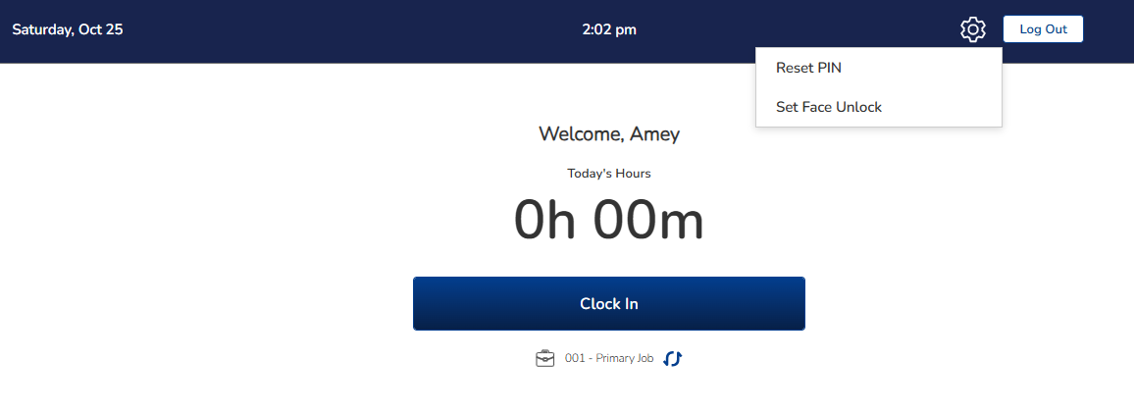

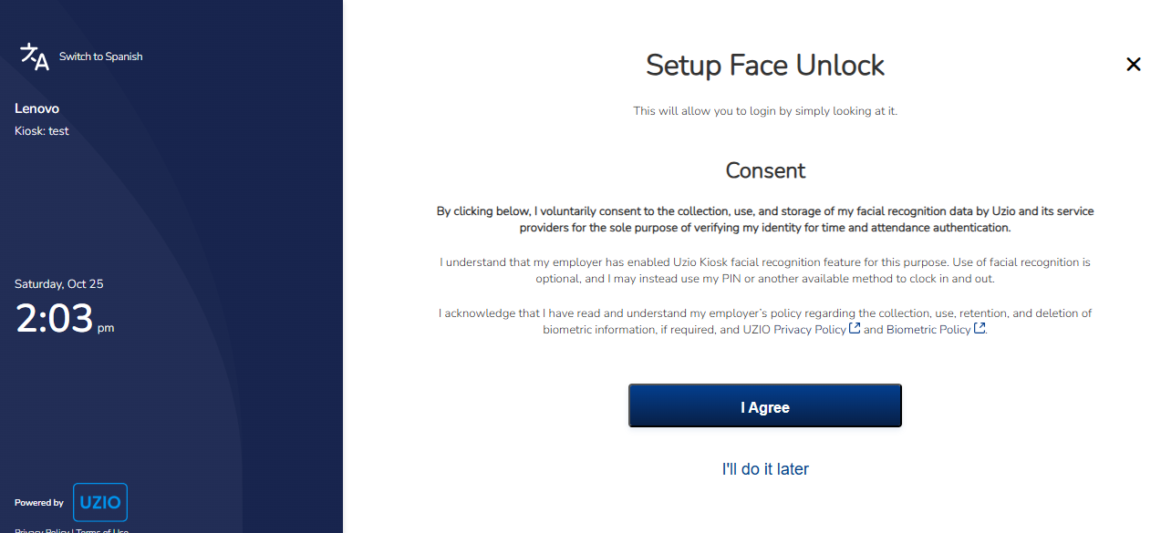

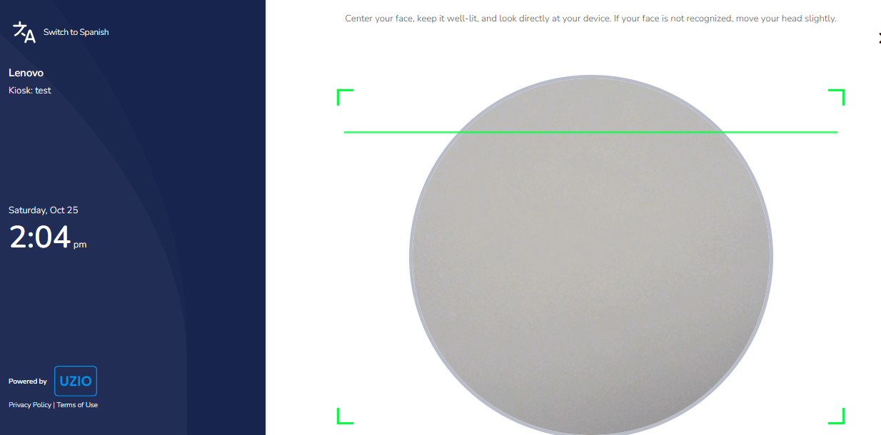

* **Setting up Face Data on the Mobile App**Open the app → Menu → Kiosk Login, Select Set Up Face Scan, Review and accept consent, Capture face; enrollment is saved for kiosk use.

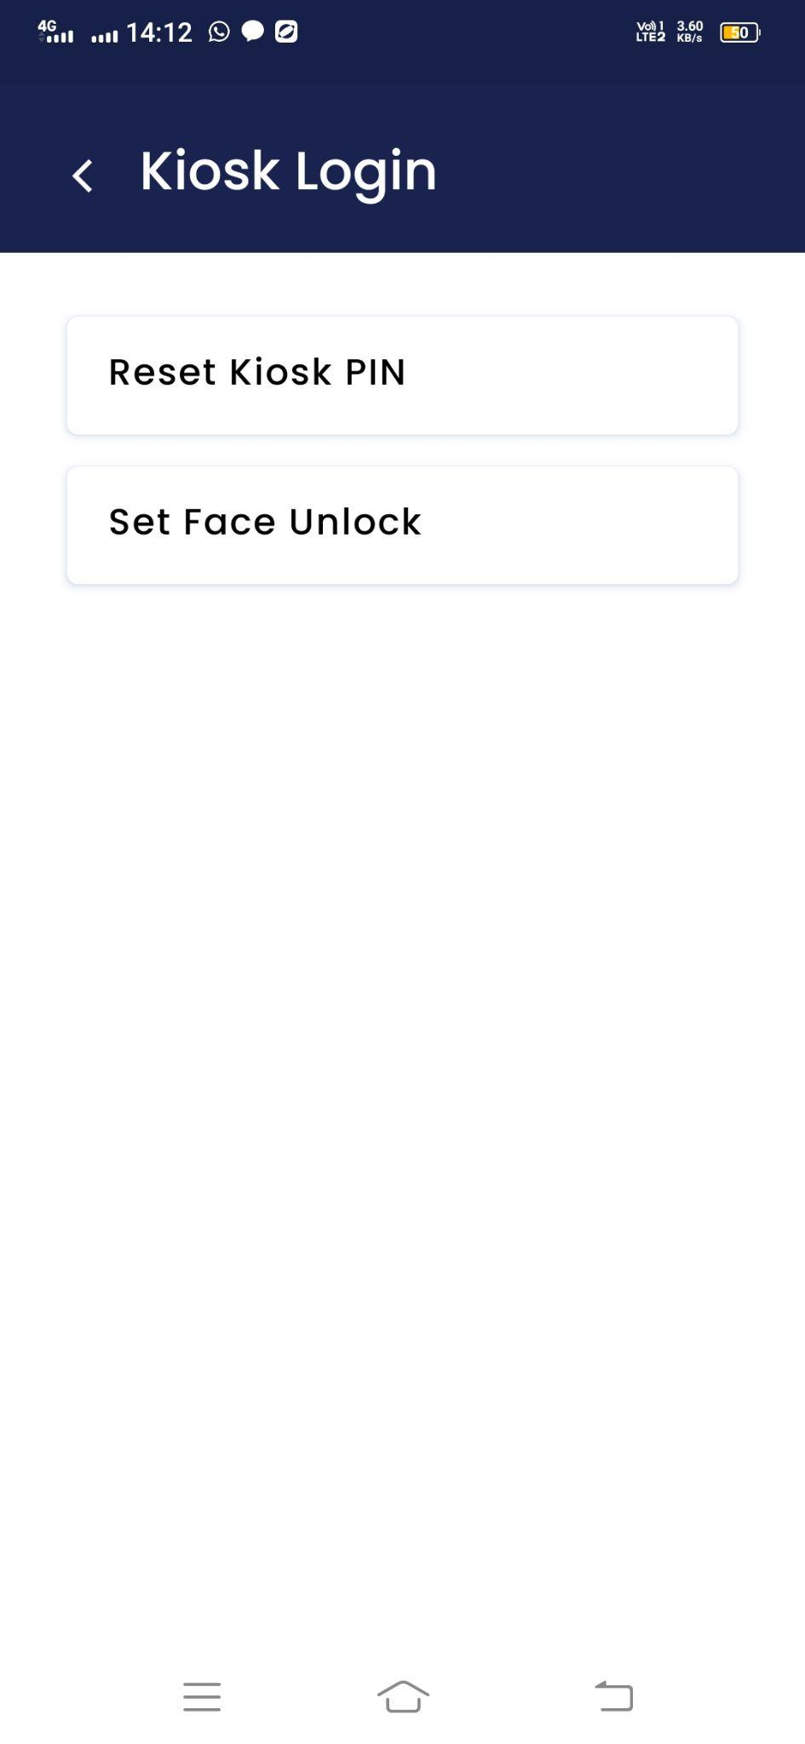 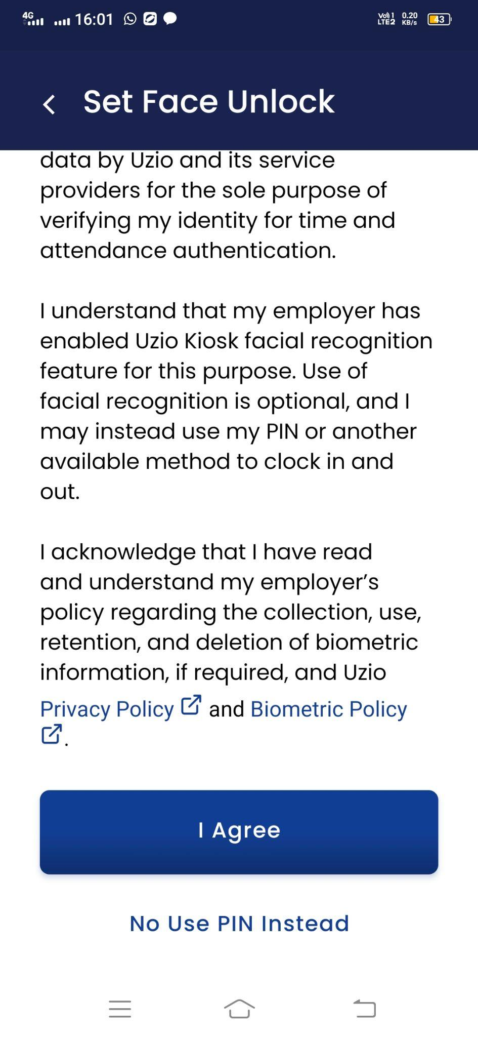 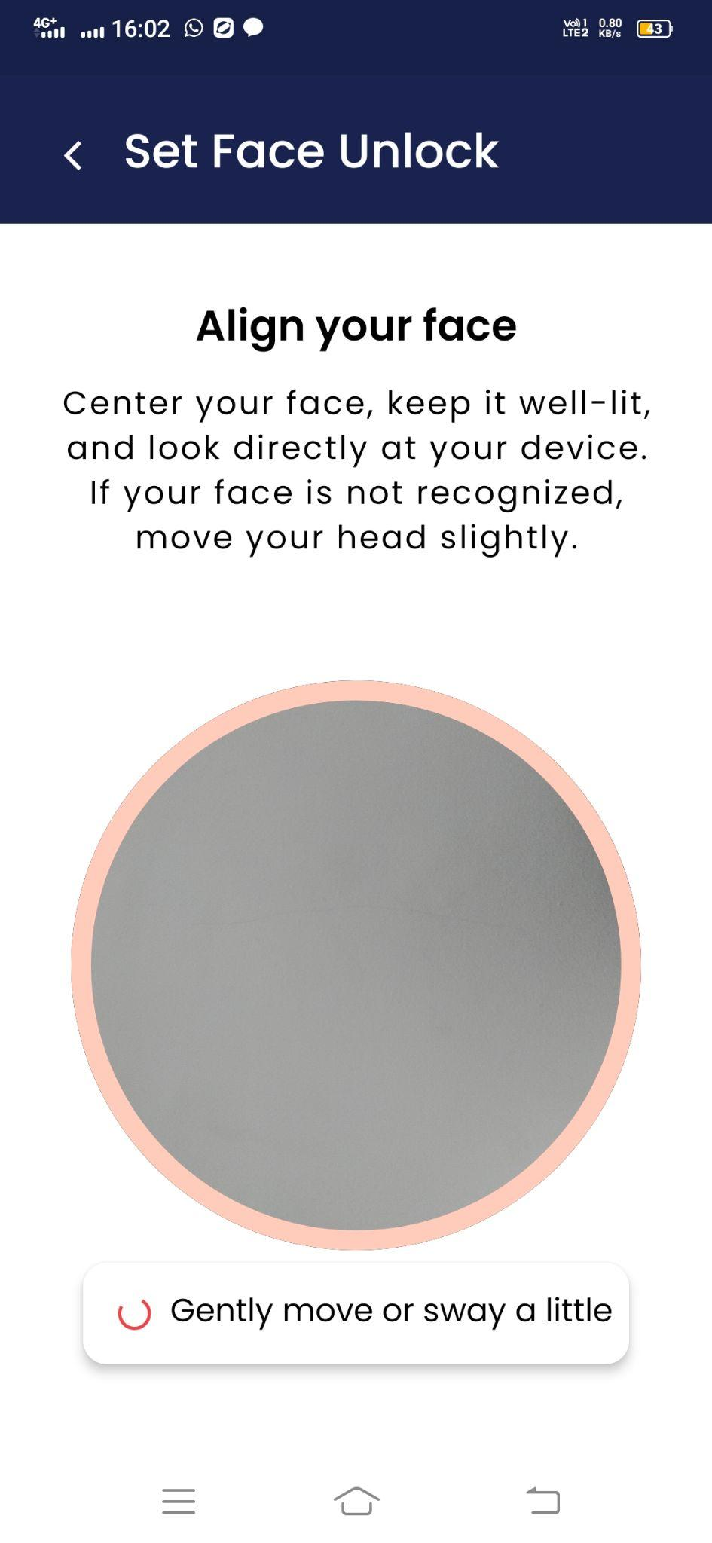

* **Manage face data-**  Employees can delete or re-enroll their face data at any time from the same Settings path on both the kiosk and the mobile app.
* **Login on Kiosk-** Once the face data is set up, the kiosk allows users to login by face or PIN. To login with PIN first locate your name on the kiosk home screen and then enter the PIN or use the option “Use Face Unlock” to scan your facial identification.

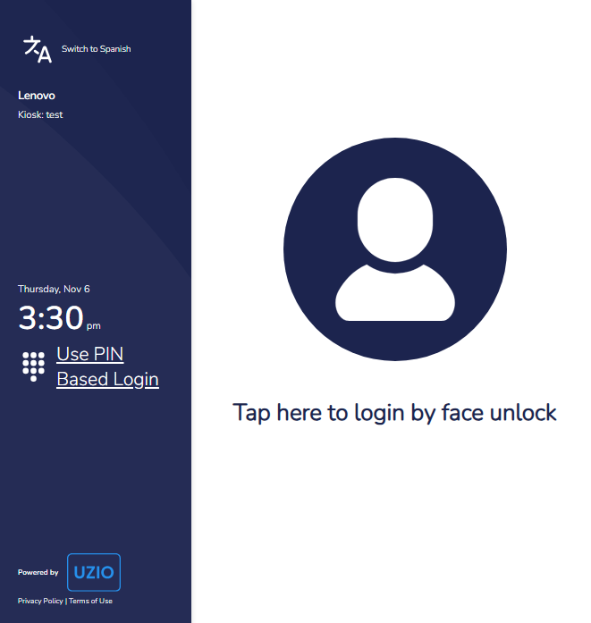

### **For Employees: Using the Time Kiosk**

#### **1. Clocking In/Out**

1. Login using your PIN or Facial Recognition.
2. Employees can track time against their **assigned shifts** and assigned jobs on the kiosk. On the home page, if the previously selected shift and job looks good to the employee, they can directly click on the “Clock IN” button.
3. Else, from the home page, employees can select the “Shift” first.Once an employee selects the shift the next screen appears to select the “Job”. After selecting the job the employee gets clock into the select shift and job.
4. Shift selection is **auto-preselected** to speed up clock-ins. If the current time falls within a scheduled shift, that shift is preselected. If no shift is active but another is scheduled later the same day, the **nearest upcoming** shift is preselected. If the employee has **no shift assigned** for that date, the shift selector droplist is hidden.
5. The job selection is dependent on the Shift. If the selected shift has a designated job then after selecting the shift, the job selection screen does not appear and employee directly clock in to the designated job of the shift.If the shift does not have a designated job then employee can choose the job as per the assigned jobs.
6. Employees can choose **Unscheduled** shifts if they’re working outside scheduled hours. Unless the employer enforces restrictions (e.g. **prevent early clock-ins**), employees may select **any** shift scheduled for that day.
7. After clock-in, the user will be auto logged out in 5 seconds.

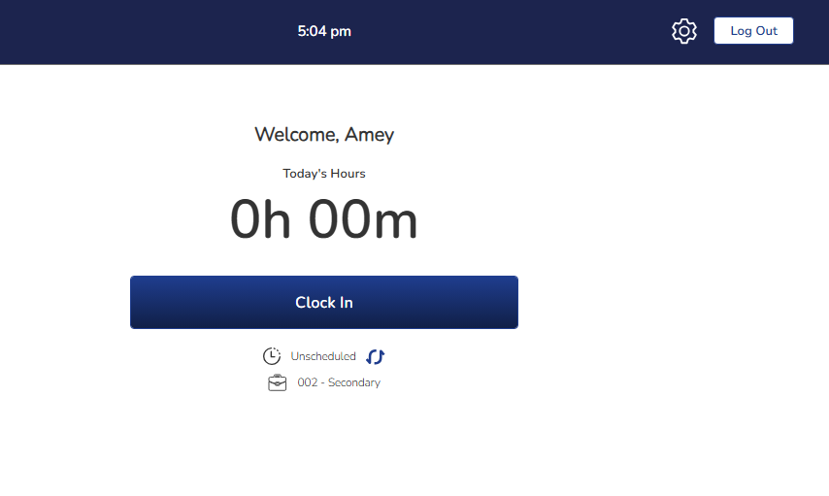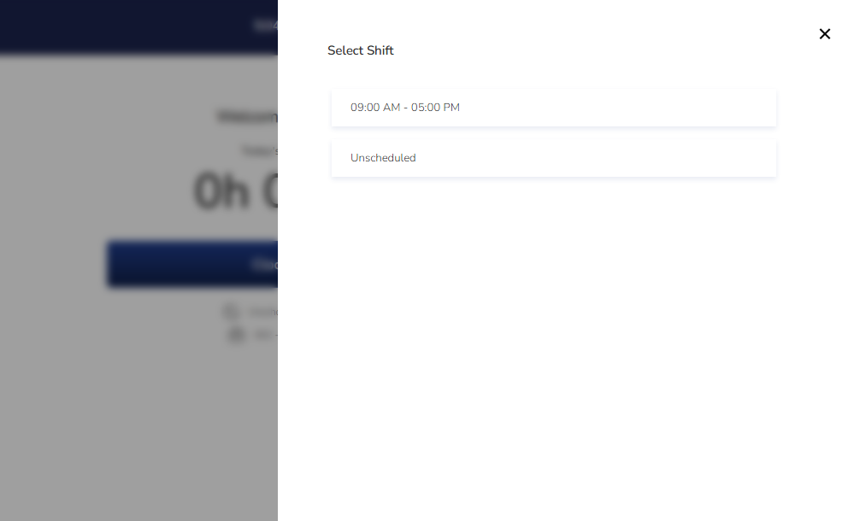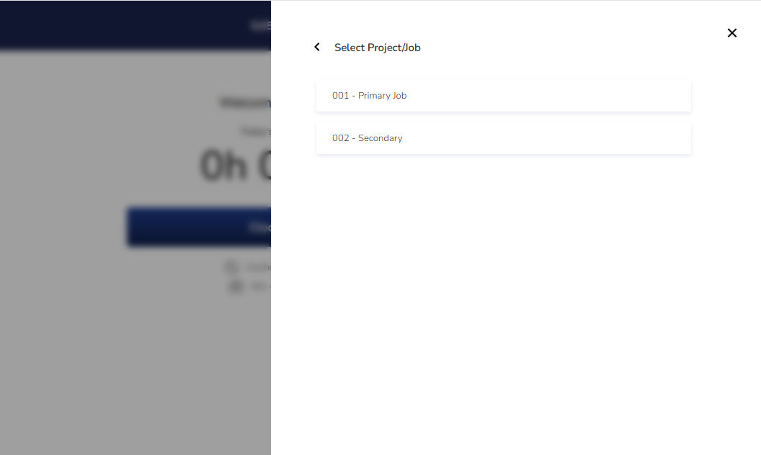

#### **2. Taking Breaks**

The kiosk allows you to log your breaks, ensuring that your working hours and break times are accurately recorded:

1. **Starting a break**
   1. Login using your PIN or Facial Recognition.
   2. Click **Start Break In**.
   3. If you have multiple break types (e.g., meal break, rest break), the system will ask you to choose the appropriate one else system will start the assigned break instantly.
   4. After break-in, the user will be auto logged out in 5 seconds.

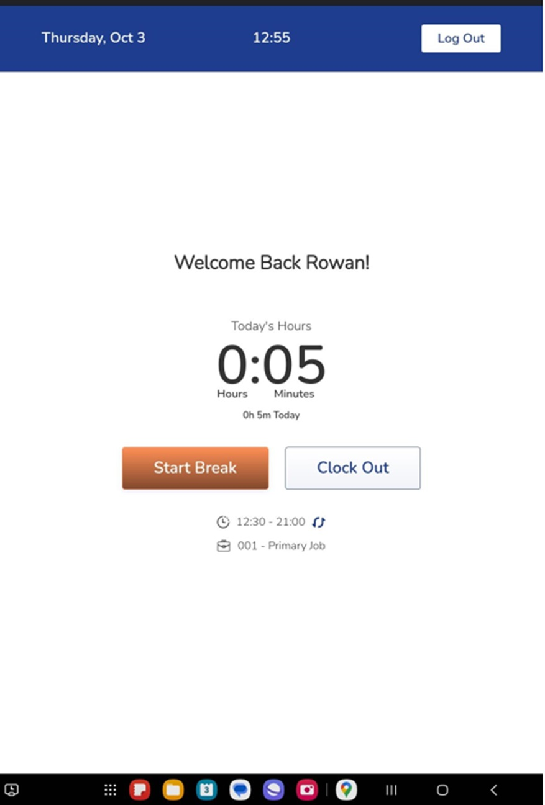

1. **Ending a Break**
   1. Login using your PIN or Facial Recognition.
   2. Click **End Break and Clock IN** to end the break and the working hours will be resumed.
   3. Click **Clock Out** to end the break as well as clock out from the working hours.
   4. After break-in, the user will be auto logged out in 5 seconds.

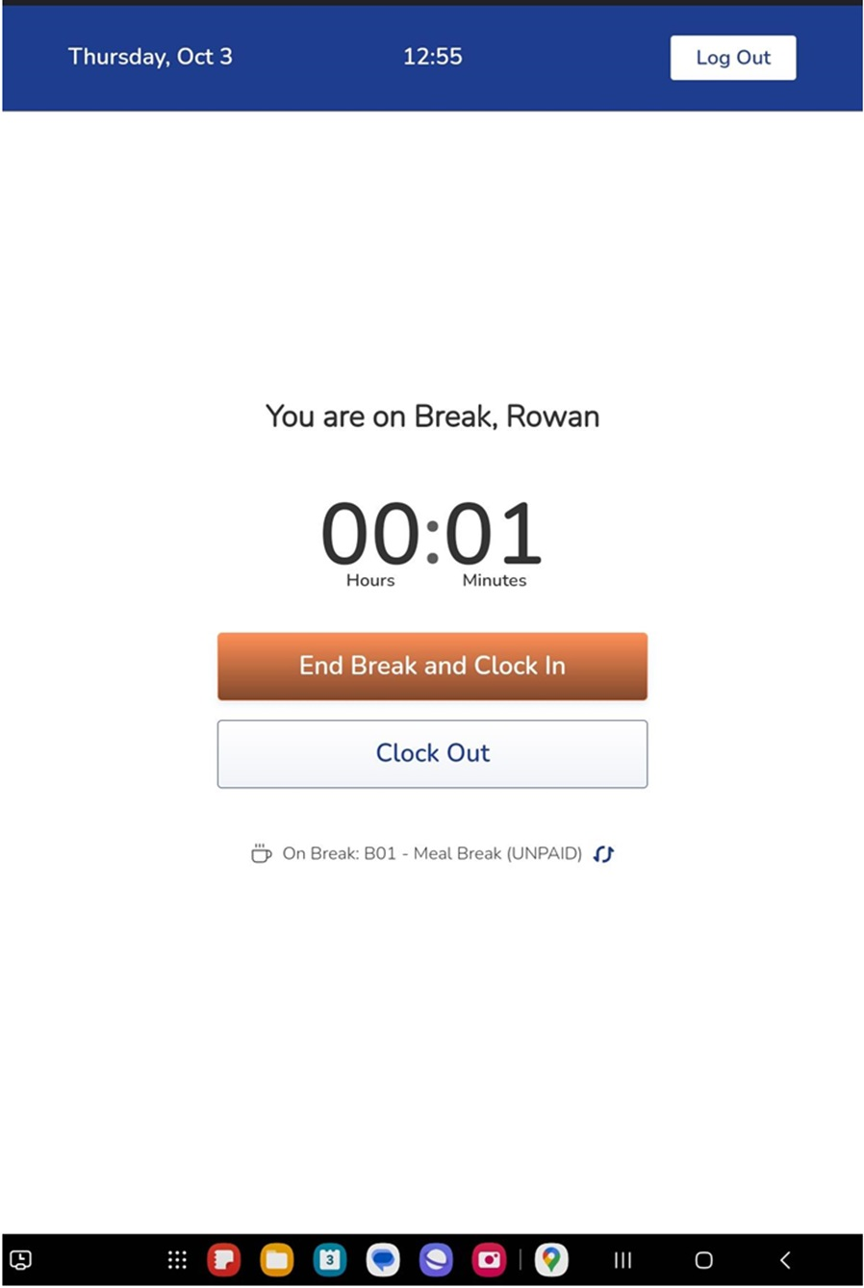

#### 

#### **Managing Employee Access and Security**

* **Forgotten PIN**: Employees who forget their PIN can reset it through multiple options:
  1. Click on **Forgot PIN** on the kiosk to receive an email/SMS with the PIN.

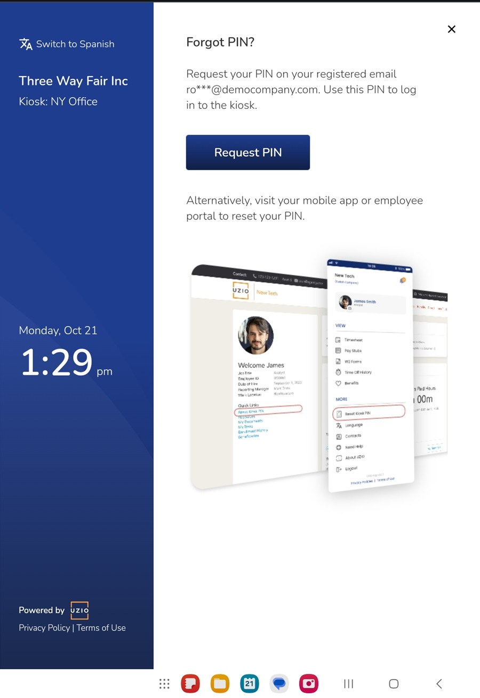

1. Use the employee portal or mobile app to reset their PIN

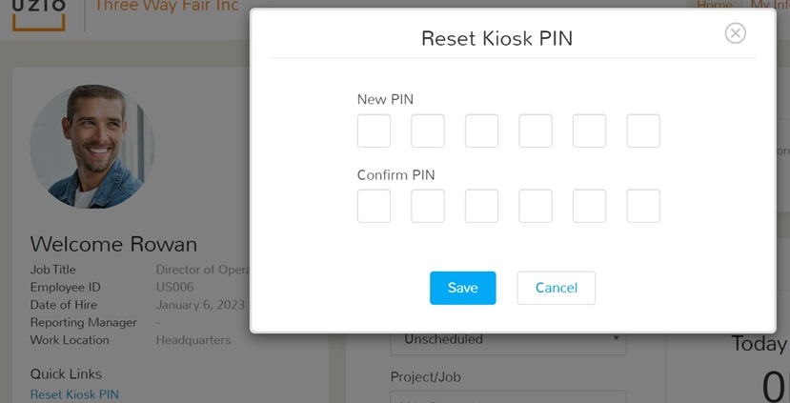

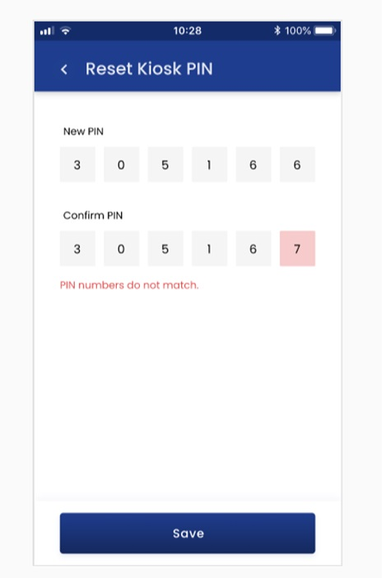

1. Request a manager to reset their PIN on their behalf, which will trigger a notification to their registered email and phone number.

* **Resetting PINs for Employees**Administrators or managers can reset employee PINs through the employer portal by navigating to the employee’s **Login Accounts** section or using the **Reset Kiosk PIN** quick link, accessible from the employee portal’s homepage by impersonating the employee’s account. This feature is especially useful when an employee encounters PIN-related issues or requires immediate access to the kiosk

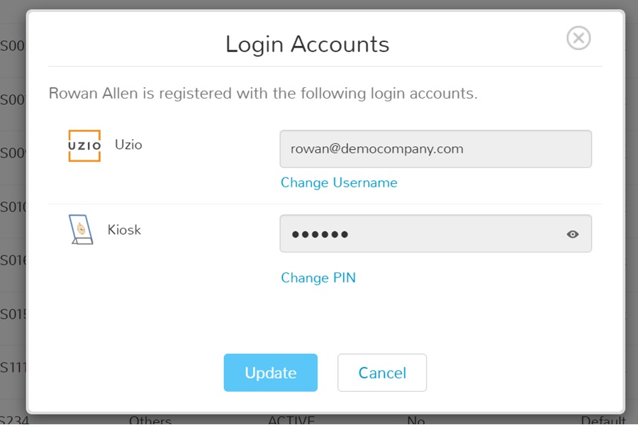

#### **Photo Security: Enhancing Accountability**

Photo security provides an added layer of verification for employee clock-ins and clock-outs by capturing a photo during these actions. This is especially useful in environments where it's important to ensure that the person clocking in or out is the actual employee assigned to that shift. The photos will be added to the time entries on employee timesheets for verification.

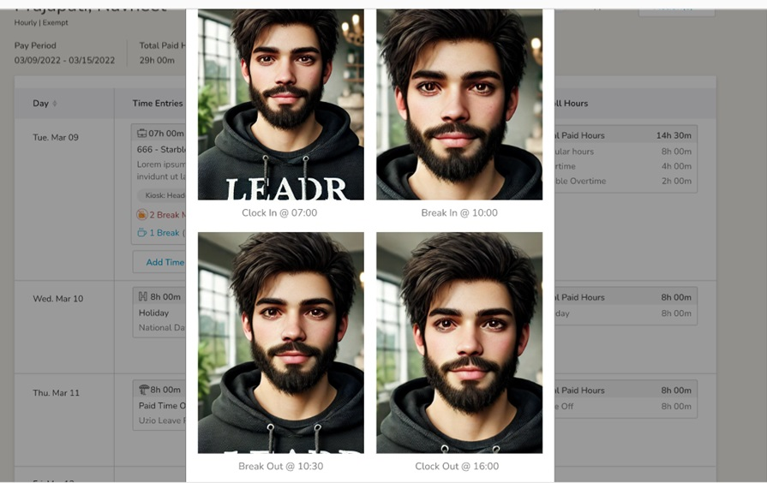

1. **Enable Photo Security**This feature can be turned on during the kiosk setup or later. Once enabled, employees will be required to allow camera access for the kiosk to function correctly.
2. **Browser Camera Permissions**
   * Ensure that the browser on the device where the kiosk is installed has access to the device’s camera. A permission prompt will appear when the kiosk is first accessed.
   * If the camera is denied permission, administrators will need to adjust the settings in the browser to grant access.
3. **Legal Compliance**
   * **Employee Consent**: It's essential to obtain explicit written consent from employees before activating photo security. Make sure employees are aware of how their photos will be used, stored, and for how long.
   * **Compliance with State Laws**: States like Illinois, Maryland, and Oregon have specific restrictions on biometric data and facial recognition. Regularly review privacy and biometric laws in your area to ensure compliance.

#### **3. Troubleshooting PIN Issues**

* **Forgotten PIN**: Tap the **Forgot PIN** button on the kiosk login screen. You'll receive your PIN via your registered email and SMS Text ((if phone number is provided).
* **Reset PIN**: You can reset your PIN through the employee portal by using the **Reset Kiosk PIN** link available under the **Quick Links** section. If you are using the mobile app, you can find the same option under the **Biometric Login menu.** Alternatively, you can ask your manager to reset the PIN for you.

### **Device Requirements & Recommendations**

To ensure optimal performance, follow these guidelines for selecting and setting up a Time Kiosk device:

* **Supported Devices**: Tablets and computers with internet access are supported. While mobile phones are not recommended due to screen resolution limitations, tablets with a screen size of 8 to 12 inches better user experience.
* **Browser Compatibility**: The kiosk supports the latest four versions of the following browsers:
  + Chrome (Desktop, iOS, Android)
  + Safari (Desktop, iOS)
  + Firefox
  + Edge

If using an Android tablet, make sure you are not running the kiosk in the desktop mode.

* **Operating System (OS)**: Ensure that your device's OS is updated to support the recommended browsers.
* **Device Placement**: It is recommended that each device be dedicated solely to the kiosk. Although multiple kiosks can be set up on the same device through different browser tabs, assigning one kiosk per device minimizes confusion and ensures smooth operations.

### **Workplace Setup: Best Practices for Kiosk Placement**

For a seamless time tracking experience, follow these best practices when placing the kiosk in your workplace:

* **Location:** Place the kiosk in a convenient, easily accessible area, such as a break room or near an entrance, ensuring that all employees can clock in and out quickly.
* **Security:** Ensure that the kiosk device is secured in a tamper-proof location. Consider mounting the tablet to a stand and using locks for additional security.
* **Orientation:** If the camera on your tablet is placed along the shorter edge, use your tablet in portrait orientation. If the camera is placed along the longer edge, use it in landscape orientation.
* **Privacy:** If the Photo Security feature is enabled, respect employee privacy by avoiding placement in exposed or public areas where others may see the clock-in process.
* **Clear Instructions:** Provide clear, concise instructions next to the kiosk so that employees who are unfamiliar with the process can easily follow along.

### **Advanced Troubleshooting**

* **PIN Not Received**: Ensure the employee’s registered email (work email) and phone number available on employee’s record are correct in the system. Resend/Reset the PIN if necessary.
* **Photo Security Not Functioning**:
  + Check if the camera permissions are enabled for the browser.
  + Test the camera separately to ensure it is functional.
  + Re-enable Photo Security in the kiosk settings and refresh the page.
* **Kiosk Unresponsive**:
  + Refresh the browser page.
  + Restart the device.
  + Check for internet connectivity issues.
* **Reappearing Activation Code**:  
  This occurs when a previously activated kiosk has been deleted. Set up a new kiosk in **Time Tracking Settings** and activate it with the newly generated code.

# Using Time Tracking in Offline Mode

## Enable Time Tracking in Offline Mode

Uzio supports using limited actions of employee time tracking even if the internet connection is not available. To enable this feature follow the steps

* Login as employer admin
* Open Time Tracking Settings from the left navigation
* Go to Time Clocks and enable the setting - Enable employees to track time without an internet connection?

## What actions are allowed in offline mode

Offline time tracking features are only available for employees. Any employer level action cannot be performed in the offline mode like- Time Hours approval, syncing hours to payroll etc.

The employees can perform following actions in the offline mode

* Clock In
* Break In
* Break Out
* Clock Out

Rest other actions are disabled in the offline mode. The employee remains on the time tracking page of the mobile app. Employees cannot go to other pages in the offline mode. The app restricts the ability to move the employee on any other pages.

## How system works in offline mode

* When the employee is working offline, the app shows a tag of **“Offline”**.
* Whenever an employee performs an action in the offline mode, the system records the action in the local memory of the mobile device.
* All the actions performed on the mobile device in offline mode, the system maintains the sequence as well.
* As soon as the internet connection is restored, the system automatically starts the syncing process which usually takes 10-15 seconds. When the syncing process is in progress, the system shows a spinning wheel on the top right corner of the app that shows the progress of the syncing process.
* The syncing process includes sending the recorded actions in the offline mode to the server.

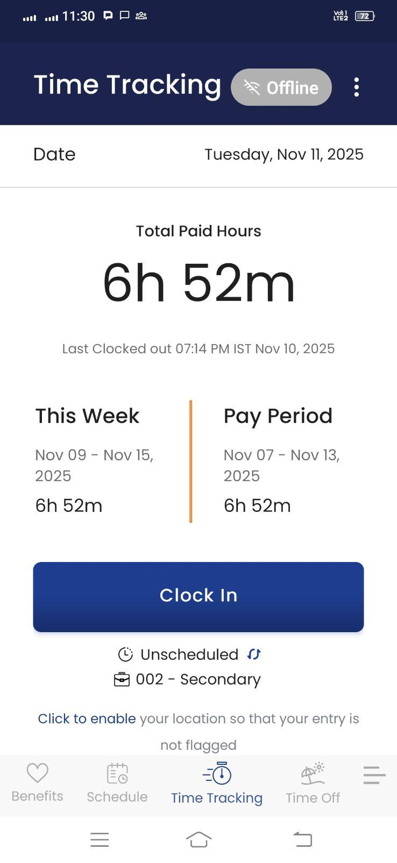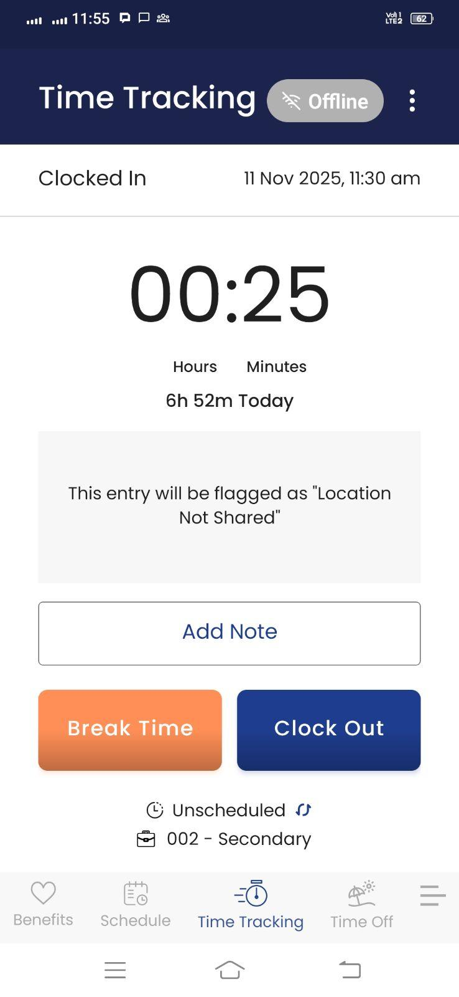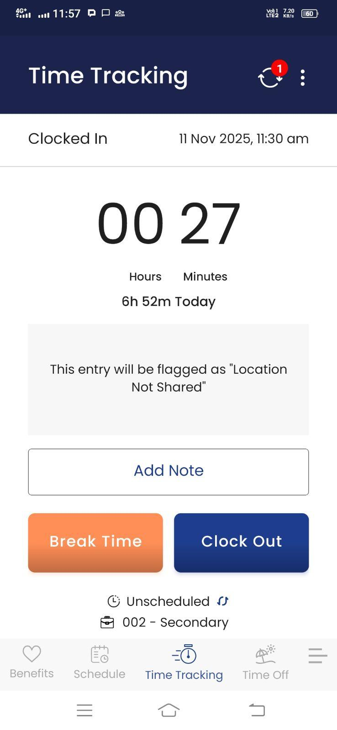

## Conflict Handling

Conflict is a situation when one time entry recorded in the offline mode is overlapping by any other time entry recorded in the online mode. Example- Employee clocked in, in the OFFLINE mode from mobile app and before internet connectivity restoration, employee also clocked in, in the ONLINE mode from web. Later on connectivity was restored on the mobile, so the system tried to sync the offline entry but found that it was overlapping with the online time entry.

When the conflicting situation occurs, the system shows the **Conflict** on the offline time entry on the mobile device. The system fails to sync the entry on the server and shows a conflict on the mobile app.

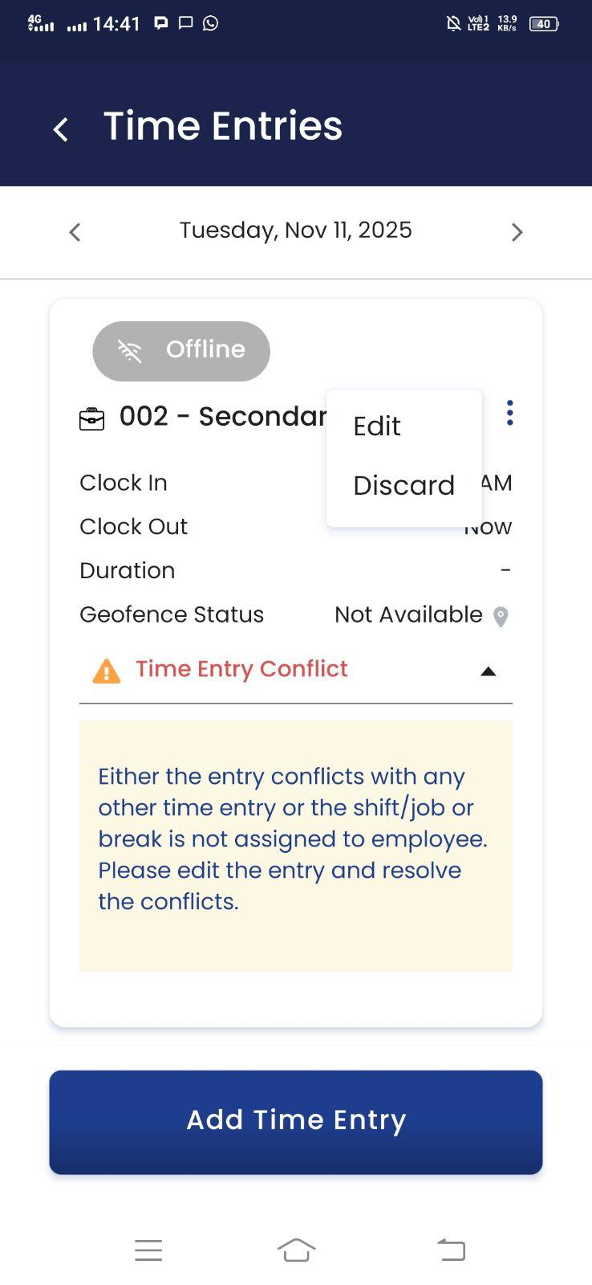

The employee has to resolve the conflict by editing the time entries on the app.

Employees have two options

### Edit

Resolution of conflict is a manual process in which employees need to fix the entries intelligently so that overlapping is resolved. The employee needs to edit the time entry to resolve the overlapping situation. Once the overlapping situation is resolved, the system automatically syncs the time entries from mobile device to server.

### Discard

Employees can discard the conflicting entry. By doing so, the conflicting offline time entry will be discarded and removed from the timesheet page on the mobile device.